Voxxil RIS

Index:

1. Introduction

2. Purpose

3. Future Scope

4. Technologies Used

5. Modules

* Super Admin Module
  + Introduction
  + Purpose
  + Modules Overview
  + Workflow
  + Screenshots
* Admin Module
  + Introduction
  + Key Features
* Patient Module
  + Introduction
  + Key Features
  + Modules Overview
  + Workflow
  + Screenshots

6. Conclusion

* Summary

INTRODUCTION

The Voxxil RIS app aims to revolutionize healthcare operations by leveraging advanced technological solutions. This comprehensive platform integrates appointment scheduling, patient management, referrals, billing and invoicing, procedure tracking, and image and report management into a unified system. By doing so, Voxxil RIS enhances operational efficiency, reduces administrative burden, and significantly improves patient care and satisfaction.

**PURPOSE**

The purpose of the Voxxil RIS web app is to streamline healthcare processes and improve patient care through advanced technological solutions. By centralizing essential functions such as appointment scheduling, patient management, referrals, billing and invoicing, alongside advanced features like procedure tracking and image/report management, Voxxil RIS empowers healthcare professionals to focus more on patient care and less on administrative tasks.

PROJECT SCOPE

The Voxxil RIS Healthcare Management System encompasses the development of integrated patient and administrative portals. Key functionalities include:

* **Appointment Scheduling**: Voxxil enables patients to conveniently book appointments online. It empowers healthcare providers with efficient schedule management and sends automated email notifications to patients, confirming their scheduled appointments.
* **Patient Management**: Voxxil allows healthcare providers to add and store patient information securely. This includes managing patient demographics, medical histories, and treatment preferences, ensuring comprehensive care coordination and personalized healthcare delivery.
* **Referrals**: Voxxil simplifies patient referrals between healthcare providers and different branches or facilities by automating the process through email notifications. This ensures efficient communication and seamless transfer of patient information, enhancing care coordination across various healthcare settings.
* **Billing and Invoicing**: Voxxil automates billing processes, allowing healthcare providers to generate accurate invoices for services rendered. This feature streamlines financial transactions within the system, ensuring efficient revenue management and compliance with billing standards.
* **Procedure Tracking**: Voxxil includes a feature for tracking patient procedures, which involves monitoring and managing the progression of medical treatments or interventions for individual patients. This functionality ensures healthcare providers can effectively follow up on scheduled procedures, monitor treatment adherence, and update patient records with the outcomes of these procedures. It helps in maintaining a comprehensive overview of patient care journeys, facilitating better decision-making and continuity of care.
* **Image and Report Management**: Voxxil's Image and Report Management feature allows healthcare providers to securely store and access medical images (like X-rays, CT scans) and reports (such as lab results, diagnostic reports) within the system. This capability enables quick retrieval of critical diagnostic information, supports informed decision-making by healthcare professionals, and ensures comprehensive documentation of patient medical history and treatment outcomes. It enhances efficiency in healthcare delivery by centralizing essential diagnostic data and facilitating seamless access across different healthcare settings.

Technologies Used

Frontend

* Framework: React.js
* State Management: Redux with Redux Toolkit for simplified state management
* **Side Effects Management**: Redux-Saga for handling asynchronous operations and side effects
* UI Components: Material-UI
* Form Handling: react-hook-form

Backend

* Runtime Environment: Node.js
* Framework: Express.js
* Authentication: JWT (JSON Web Tokens)
* ORM/ODM: Mongoose (for MongoDB)

Database

* Database: MongoDB (NoSQL) for flexible schema and scalability
* Query Language: MongoDB Query Language (MQL)

Authentication and Authorization

* Authentication: JWT (JSON Web Tokens) for secure authentication
* Authorization: Role-based access control (RBAC)

Development Tools

* Version Control: Git and GitHub for version control and collaboration
* Project Management: Trello for issue tracking and project management

MODULES

Superadmin Module

#### Introduction

The Superadmin module is a critical component of the Voxxil RIS app, designed to provide overarching control and management capabilities to the highest level of administrative users. The Superadmin has comprehensive access to all the functionalities within the system, enabling them to maintain and oversee various aspects of the healthcare operations effectively.

#### Purpose

The primary purpose of the Superadmin module is to ensure the seamless operation and management of the Voxxil RIS app. This includes overseeing user management, maintaining patient records, scheduling appointments, managing orders and procedures, handling medical images and reports, generating analytical reports, managing referrals, and configuring system settings. The Superadmin module ensures that the application runs smoothly, securely, and in compliance with healthcare regulations.

Superadmin Module User Interface Design

#### 1. Login Page

**Description**: The Login Page is the entry point for Superadmin users to access the Voxxil RIS app. It ensures secure authentication, allowing only authorized users to enter the Superadmin module.

Screenshot:

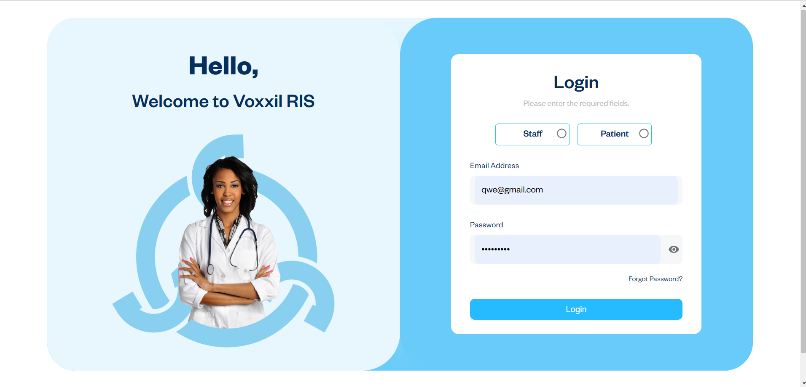

2. Superadmin Dashboard

**Description**: The Dashboard is the primary landing page after a successful login, offering a comprehensive overview of essential metrics and easy access to critical functionalities. It presents key data points, including the total number of scheduled appointments, registered patients, missed appointments, completed appointments, today's appointments, and declined referrals. Additionally, the Dashboard allows the Superadmin to view and manage data for all branches, ensuring comprehensive oversight and efficient management of the healthcare system across multiple locations.

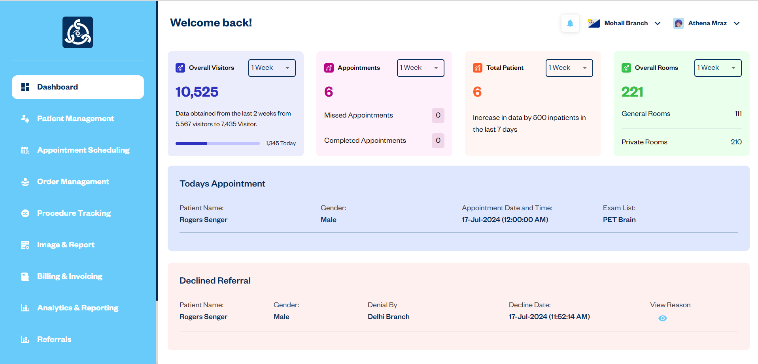

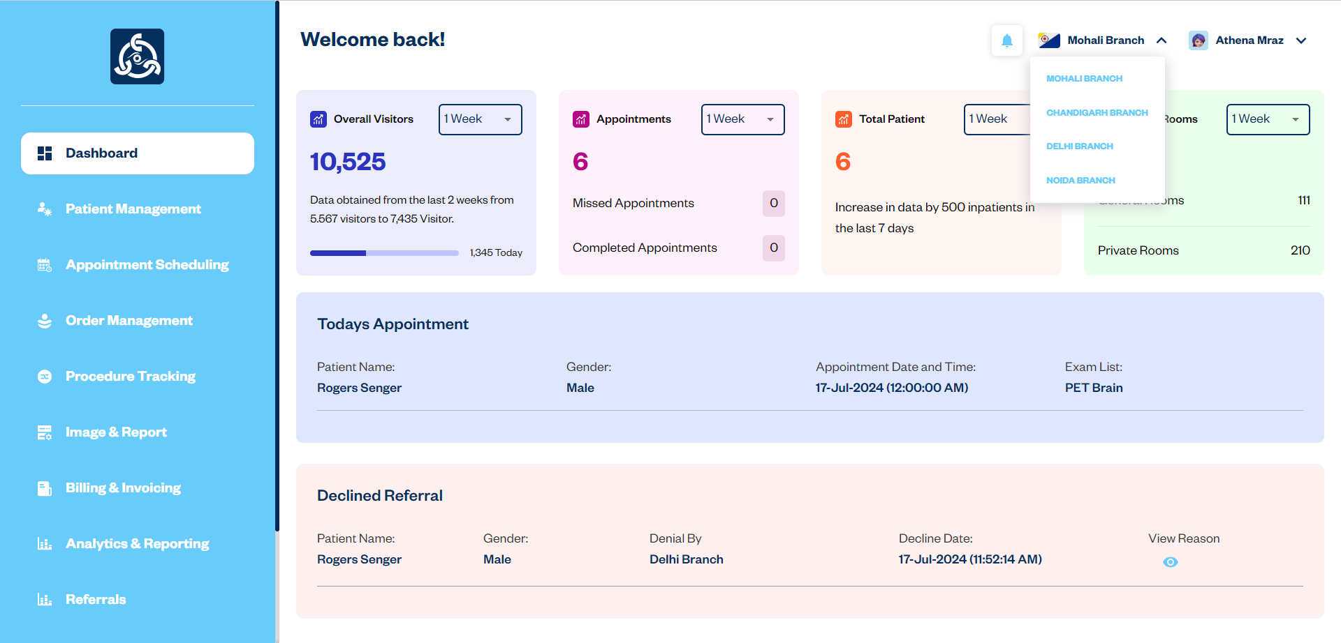

#### 3. Patient Management

**Description**: The Patient Management module allows the Superadmin to add, edit, delete and manage patient records efficiently. The Patient Management interface showing the list of patients and options to add, edit or delete records.

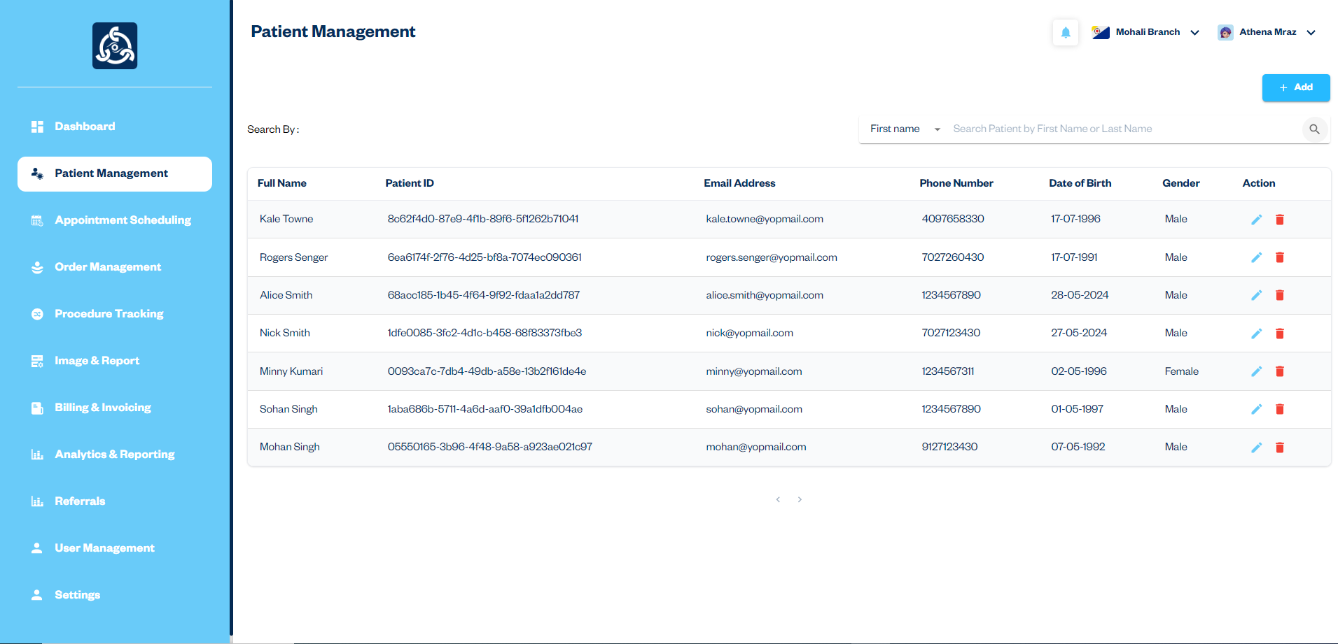

Workflow:

1. The user clicks the "Add" button to open the patient registration form.
2. The user fills out the necessary patient details and submits the form.
3. The new patient is added to the Patient List.
4. The user can edit or delete patient records from the Patient List.

#### Adding a New Patient

**Description:** Adding a new patient involves filling out a form with the patient's details and submitting it to create a new record in the system.

Step 1: Basic Information

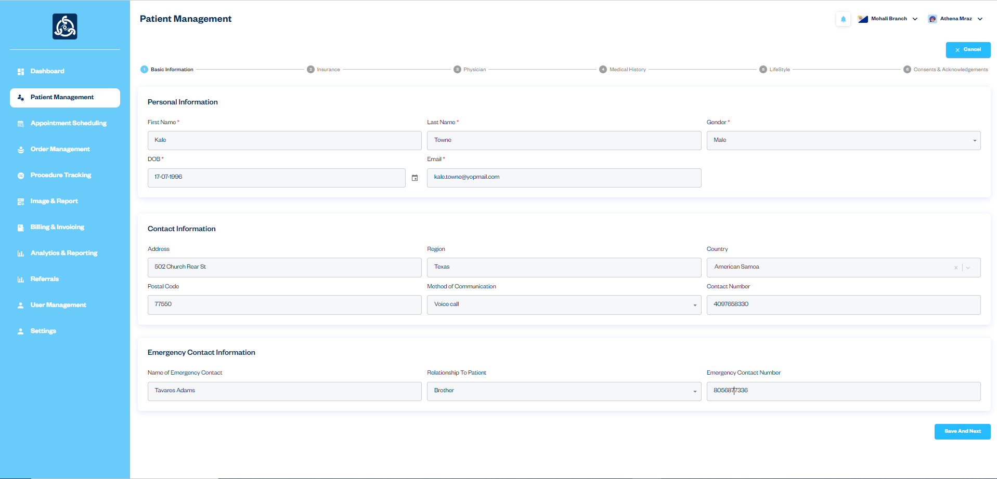

Step 2: Insurance Information

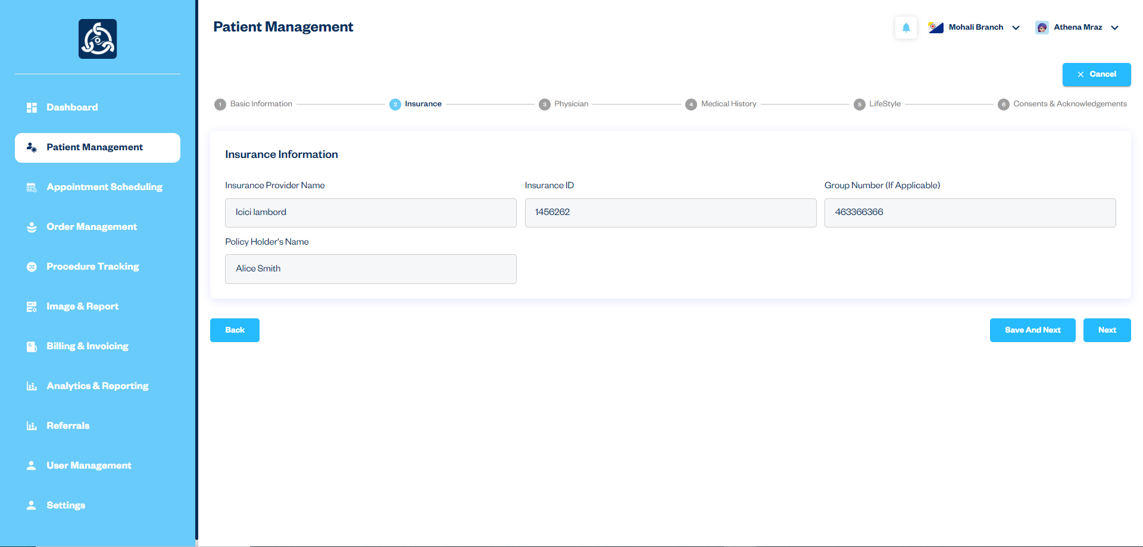

Step 3: Physician Information

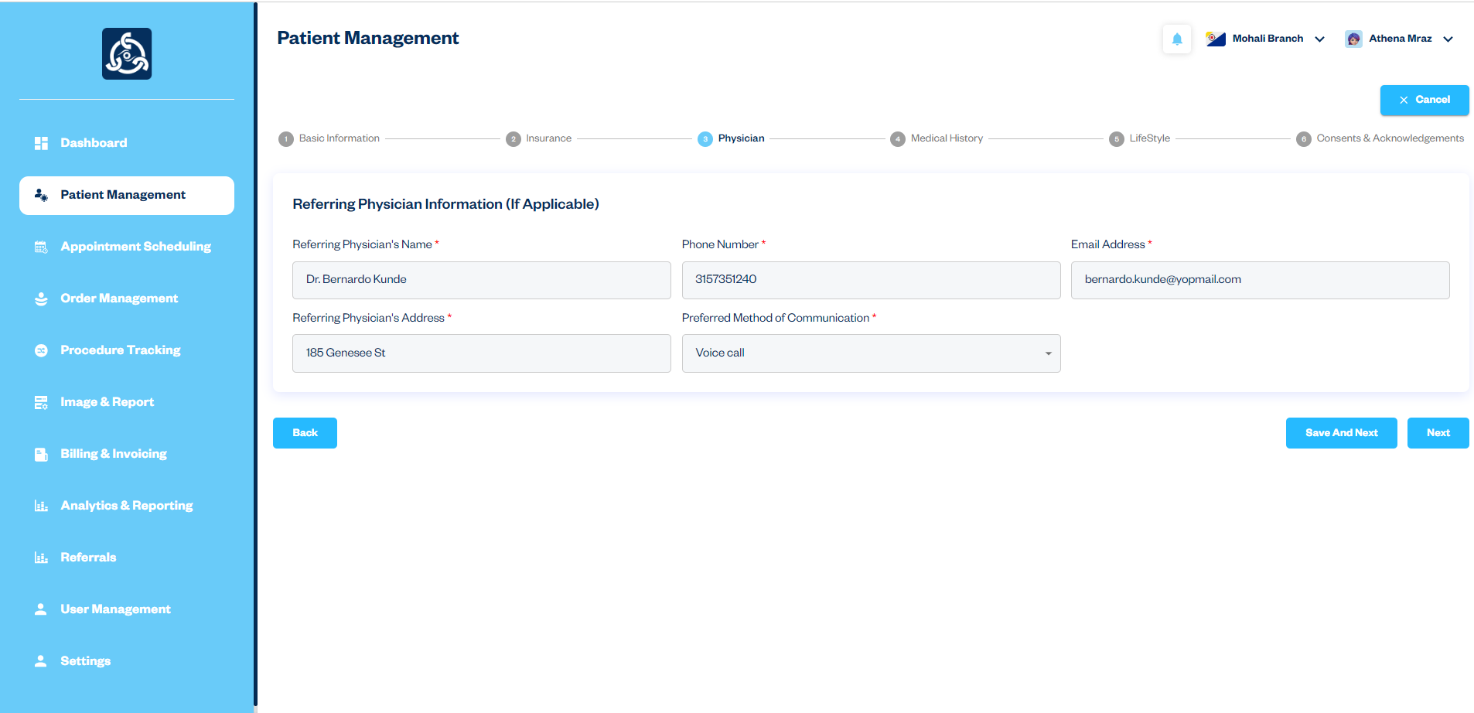

Step 4: Medical History

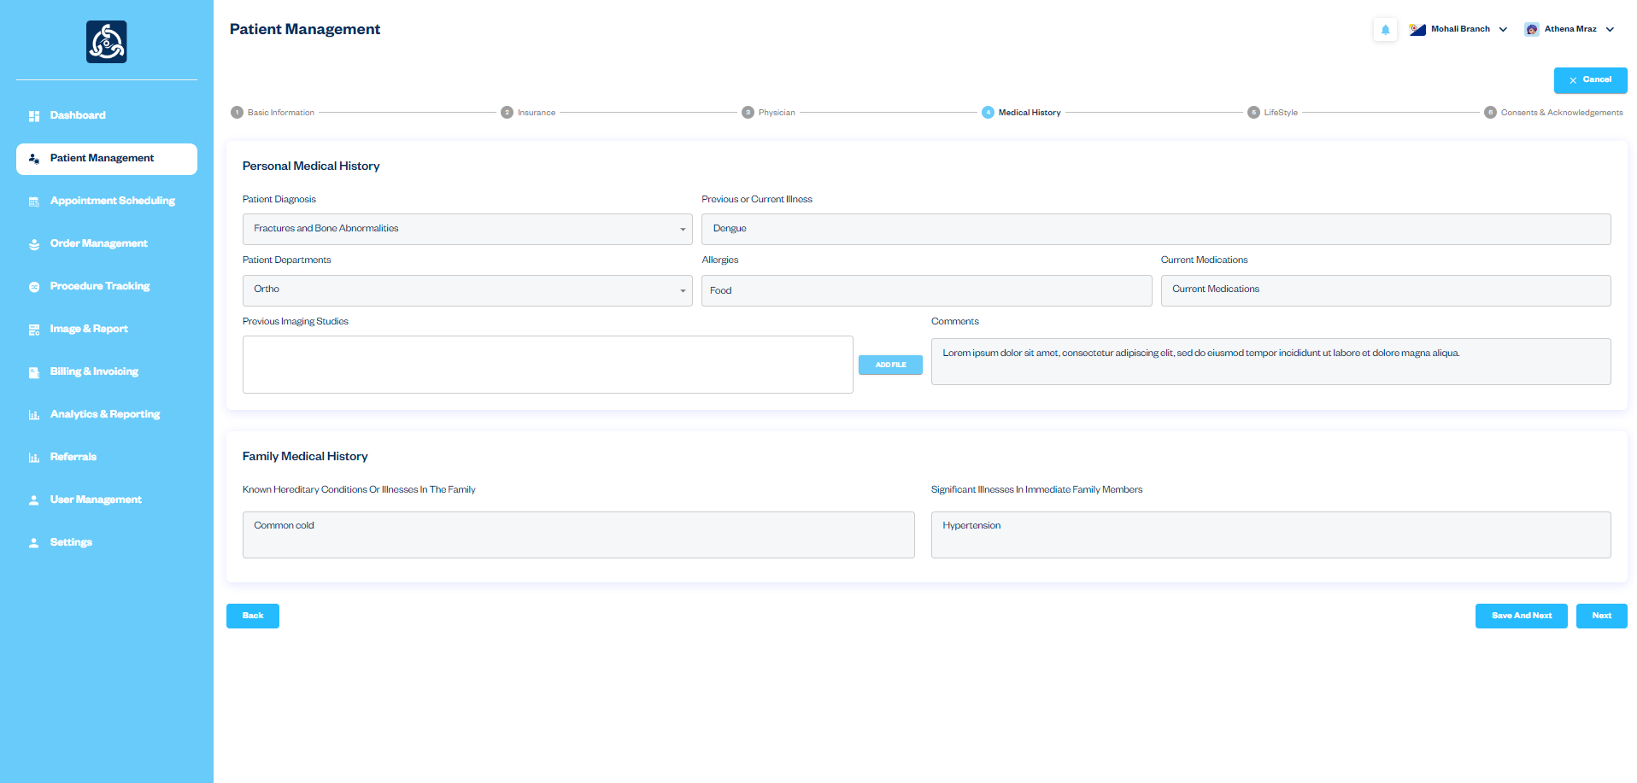

Step 5: Lifestyle Information

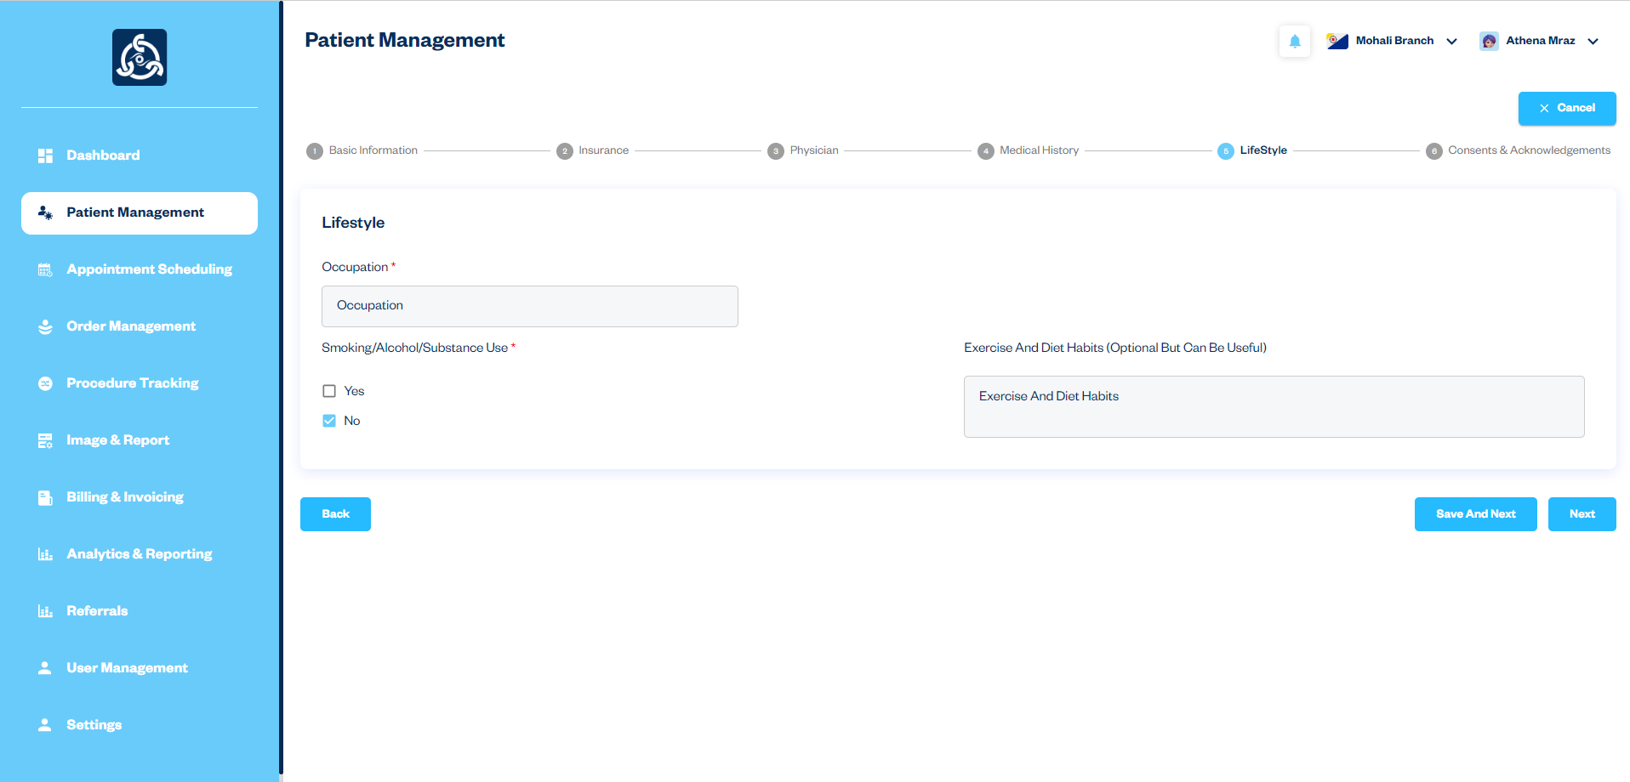

Step 6: Consents & Acknowledgements

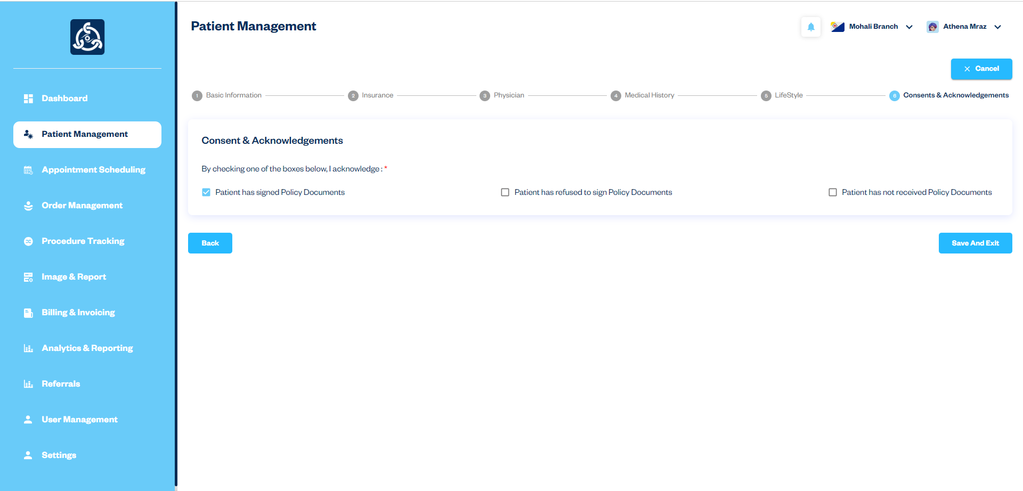

### 4. Appointment Scheduling

#### Scheduling an Appointment

**Description:** The Appointment Scheduling module allows the Superadmin to manage patient appointments efficiently. This includes scheduling new appointments, editing existing ones, and ensuring there are no conflicts in the schedule.

Workflow:

1. The Superadmin clicks on the "Appointment Scheduling" option from the side navigation.
2. A calendar view is displayed, showing all existing appointments.
3. The Superadmin clicks on the desired date on the calendar to open the appointment form.
4. The Superadmin fills out the necessary appointment details, including patient, time, and reason for the appointment.
5. The Superadmin clicks the "Save" button to submit the appointment.
6. The new appointment is added to the calendar, and the Superadmin can view, edit, or delete appointments as needed.

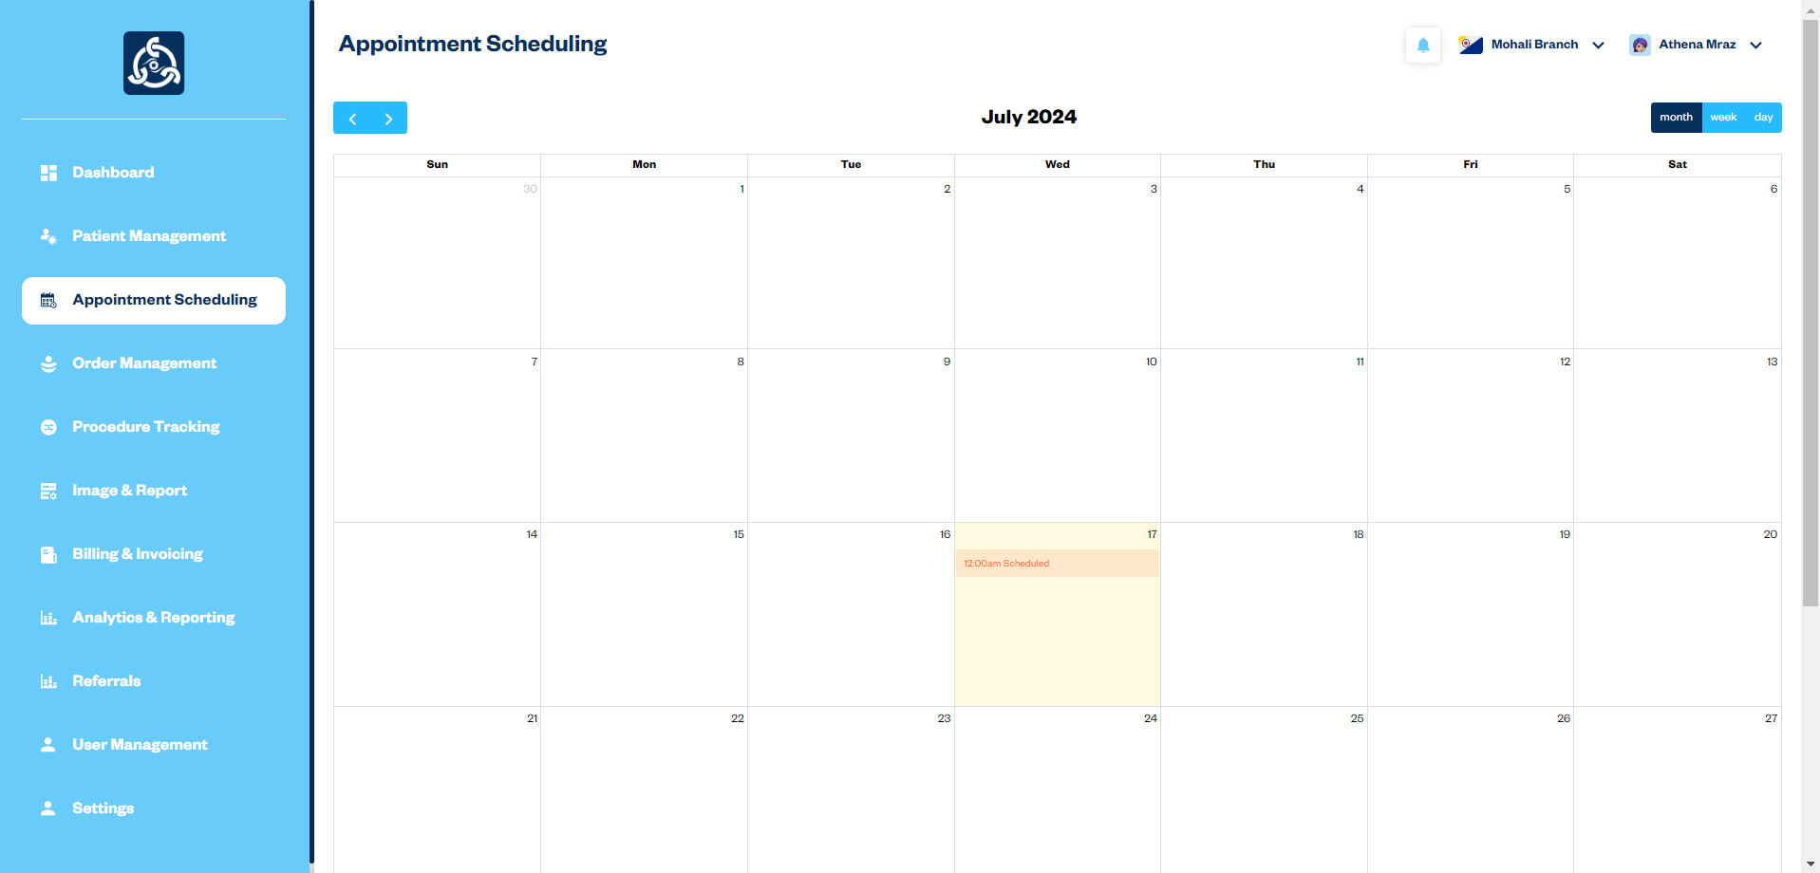

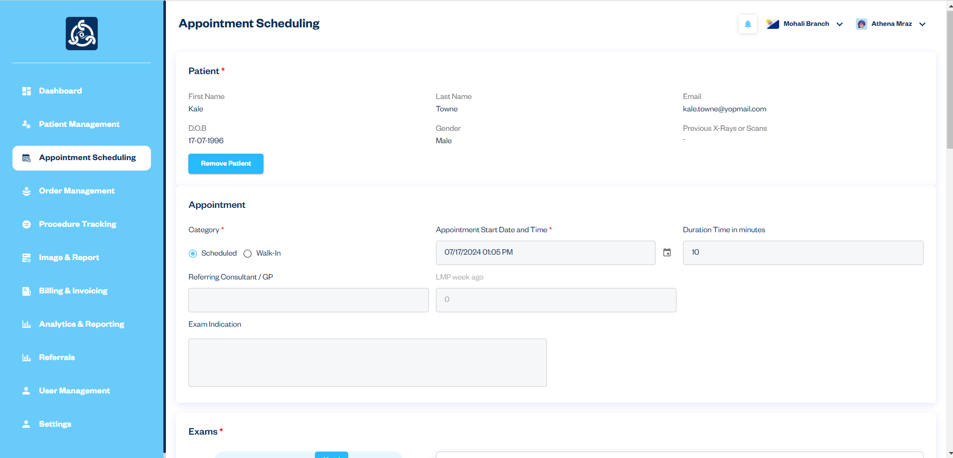

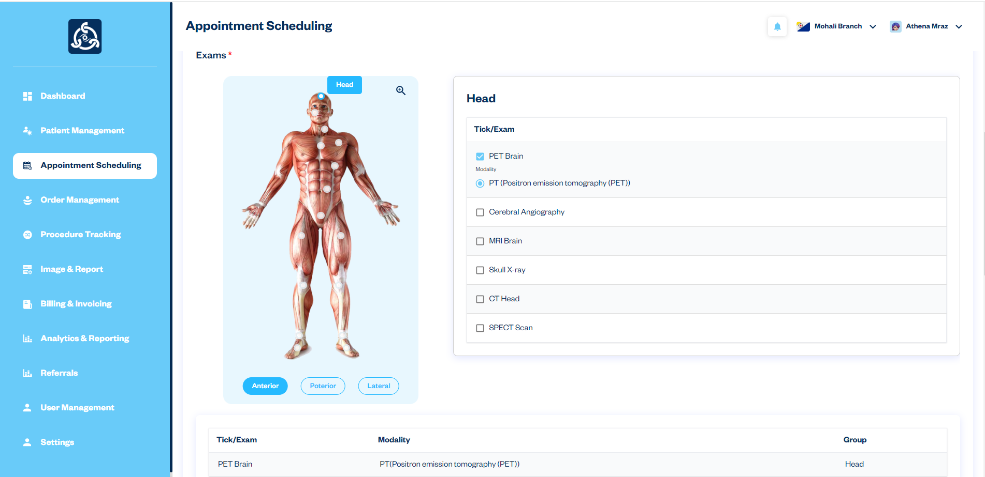

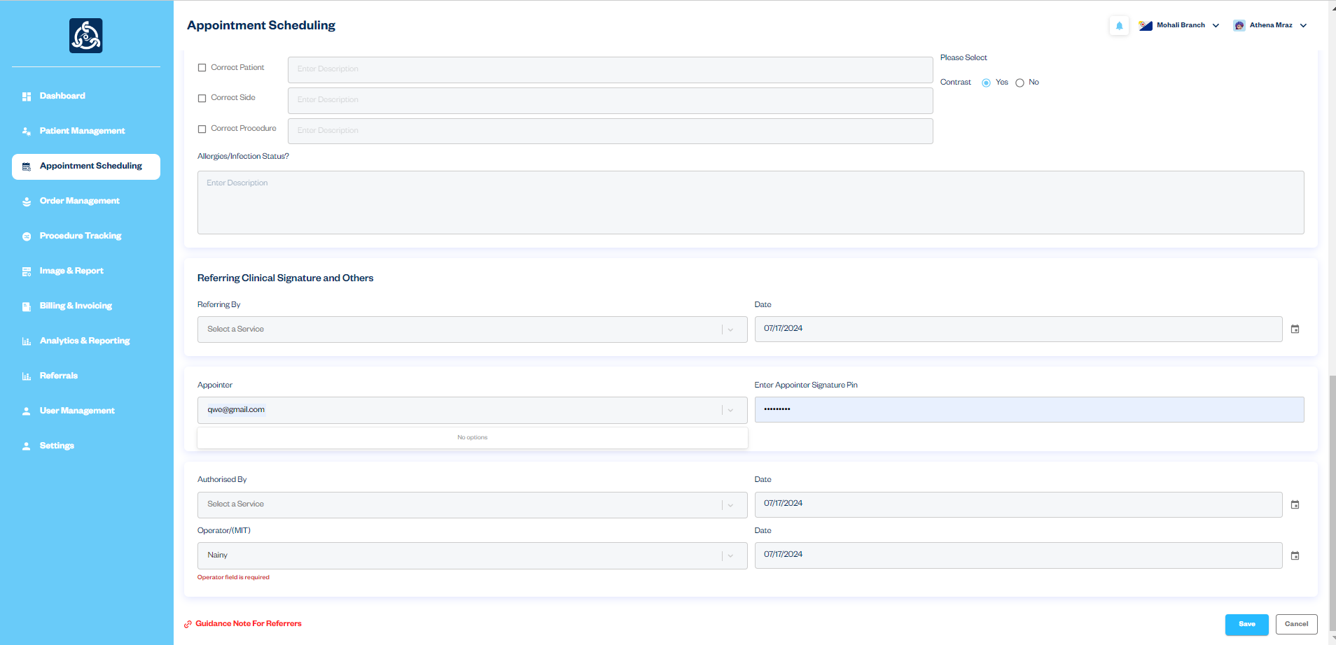

5. Order Management

Managing Orders

Description: The Order Management module enables the Superadmin to efficiently manage all scheduled appointments and create new orders. This module provides comprehensive functionality for viewing, editing, deleting appointments, and downloading or printing appointment details as a PDF.

Workflow:

1. The Superadmin accesses the "Order Management" module from the side navigation.
2. A list of all scheduled appointments is displayed.
3. The Superadmin can view details of an appointment by clicking on view icon.
4. Within the appointment details, the Superadmin can download or print the information as a PDF.
5. The Superadmin can click the "Edit" icon to modify the appointment details or the "Delete" icon to remove the appointment.
6. To create a new order, the Superadmin clicks the "+ Add" button and fills in the necessary order details.
7. The new order is saved and linked to the corresponding appointment.

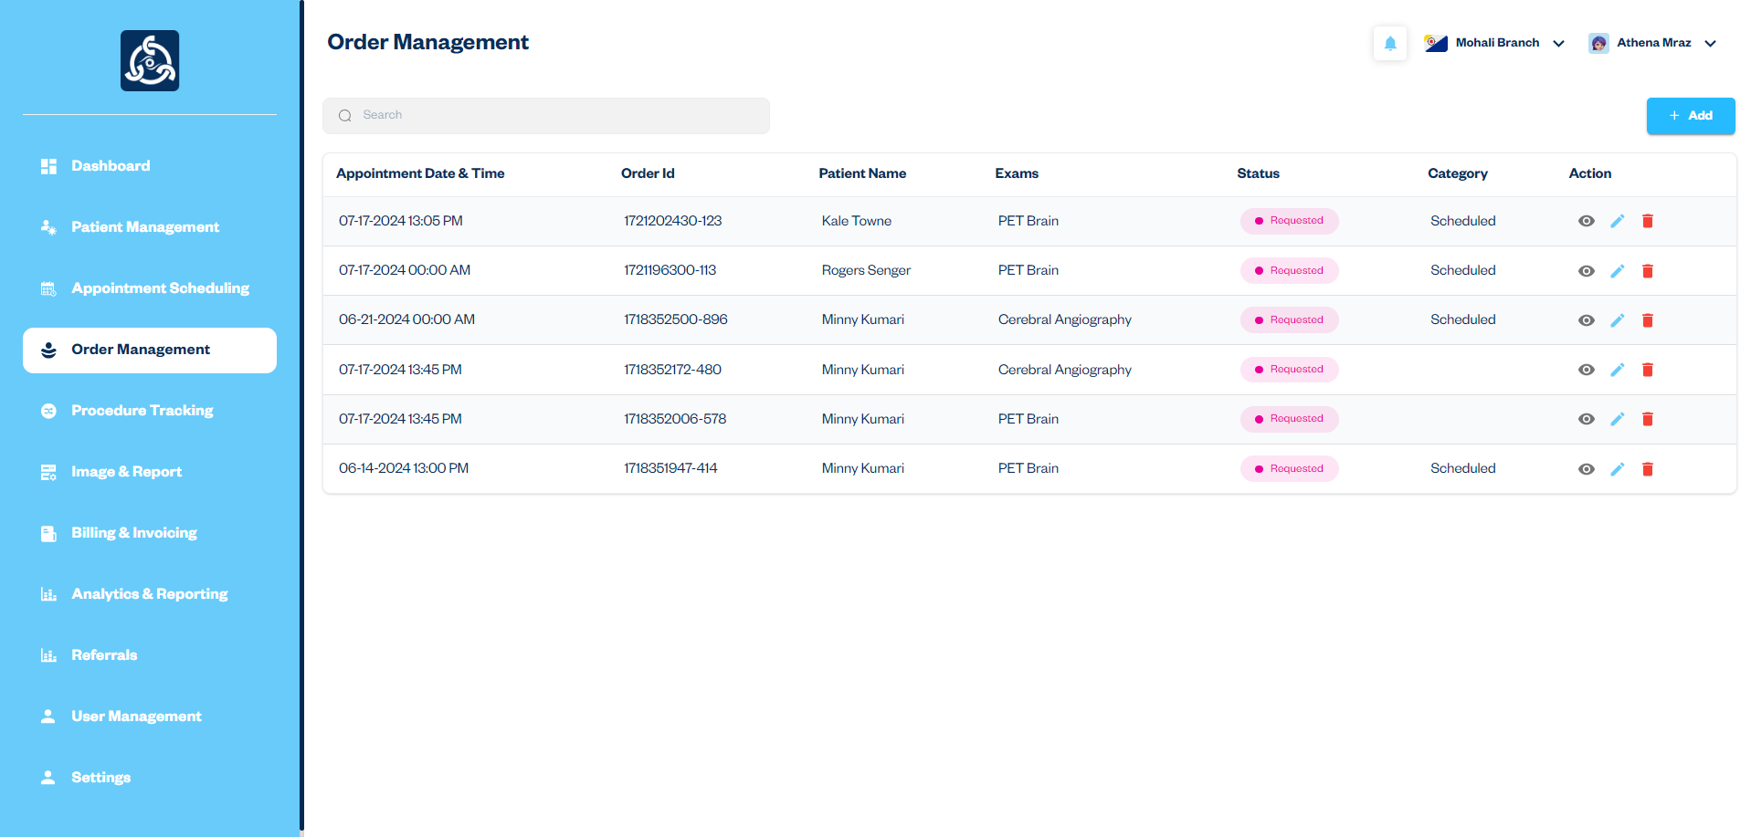

### 6. Procedure Tracking

#### Managing and Tracking Procedures

**Description:** The Procedure Tracking module allows the Superadmin to manage and monitor medical procedures efficiently by linking them to specific orders. This module provides functionality to select an order, fill out the necessary details for the subsequent process, and track the status of various medical procedures for patients, ensuring accurate and timely documentation.

**Workflow:**

1. The Superadmin accesses the "Procedure Tracking" module from the side navigation.
2. The Superadmin selects an order ID from the Order Management module.
3. Upon selecting the order ID, a form is displayed for entering the details of the procedure linked to the selected order.
4. The Superadmin fills out the necessary details in the form, including appointment status, examination content, staff and appointment signature pin.
5. The new procedure is added to the Procedure List, where its status can be tracked.
6. The Superadmin can click on a procedure to view detailed information, update the status, or add notes.
7. The Superadmin can use the search bar to quickly find specific procedures by entering relevant keywords.

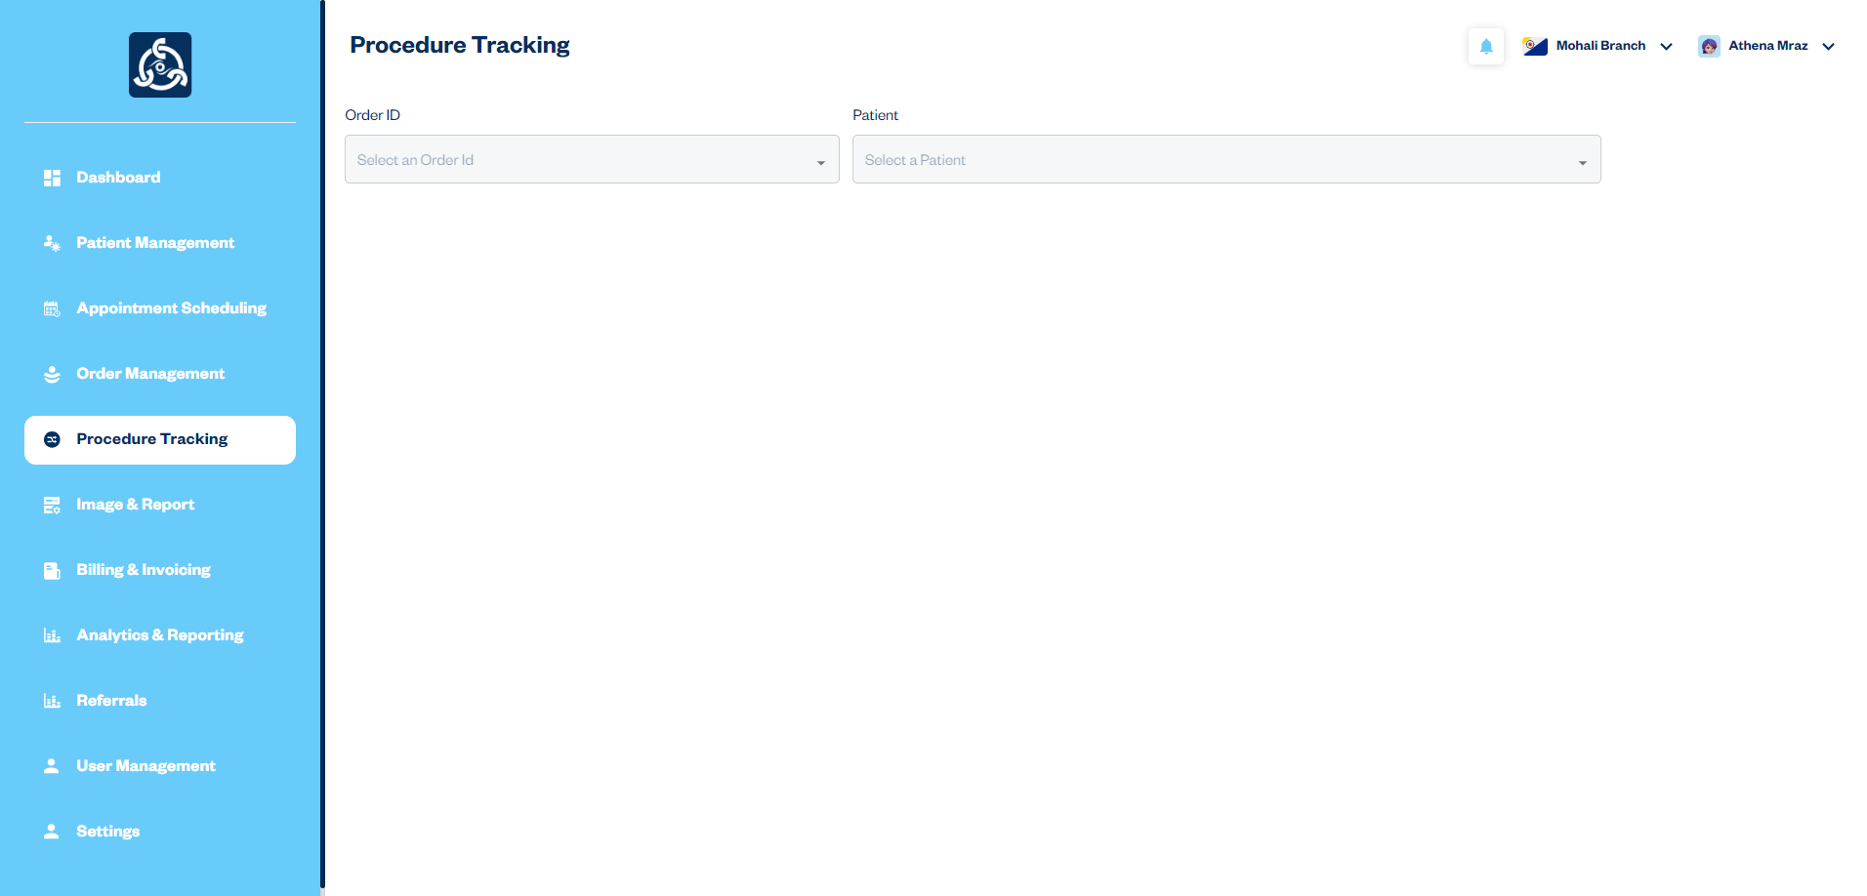

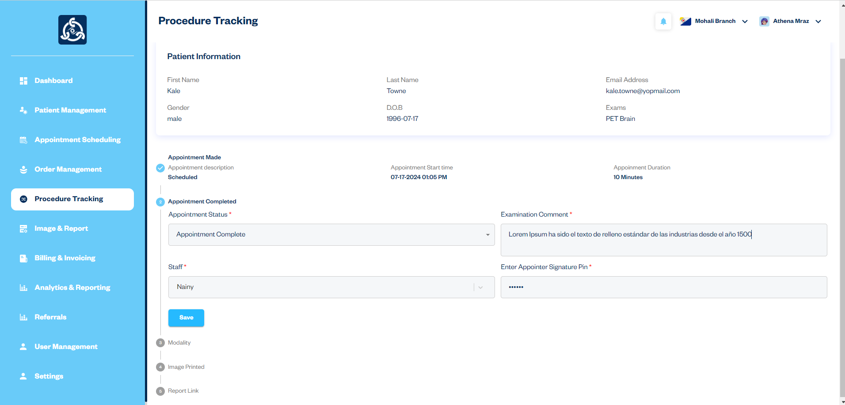

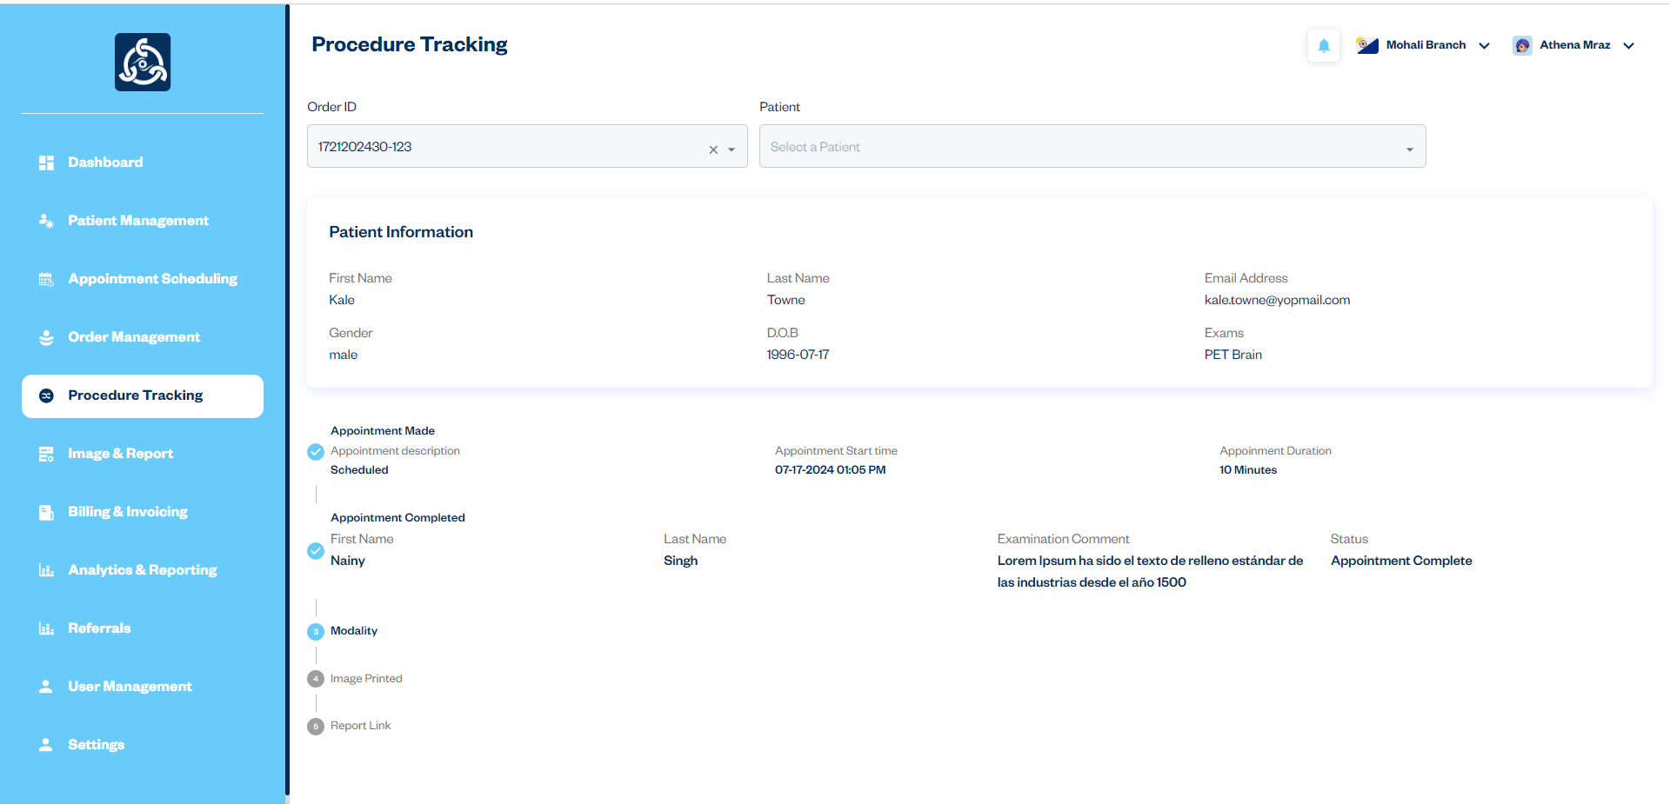

7. Image & Report

Managing Images and Reports

Description: The Image and Report module allows the Superadmin to view and manage all procedures added through the Procedure Tracking module. This module provides comprehensive functionality for processing images and reports associated with each procedure, ensuring accurate and timely documentation and follow-up.

Workflow:

1. The Superadmin accesses the "Image and Report" module from the side navigation.
2. A list of all procedures is displayed, showing detailed information and options to manage each procedure.
3. The Superadmin clicks on a procedure to view its details.
4. The Superadmin uses the "+" icon to open the create report form.
5. The Superadmin fills out the create report form with the necessary details, including patient information, findings.
6. The Superadmin can download or print the reports and images as a PDF for documentation or sharing purposes.

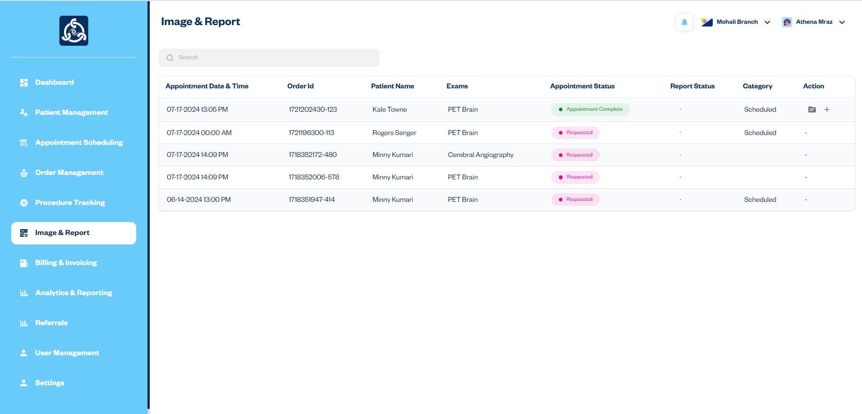

Create Report Form

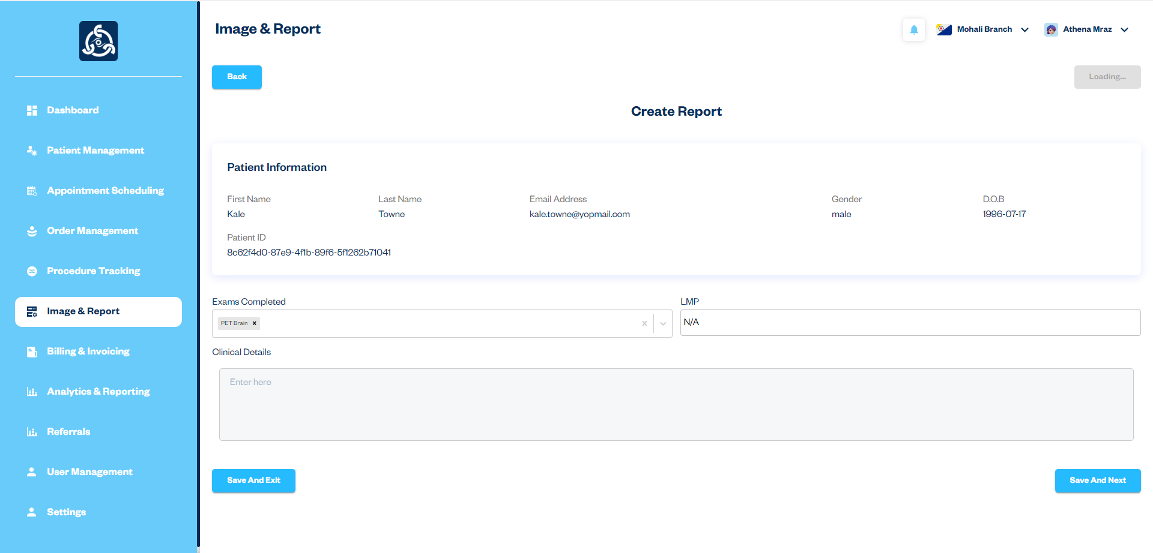

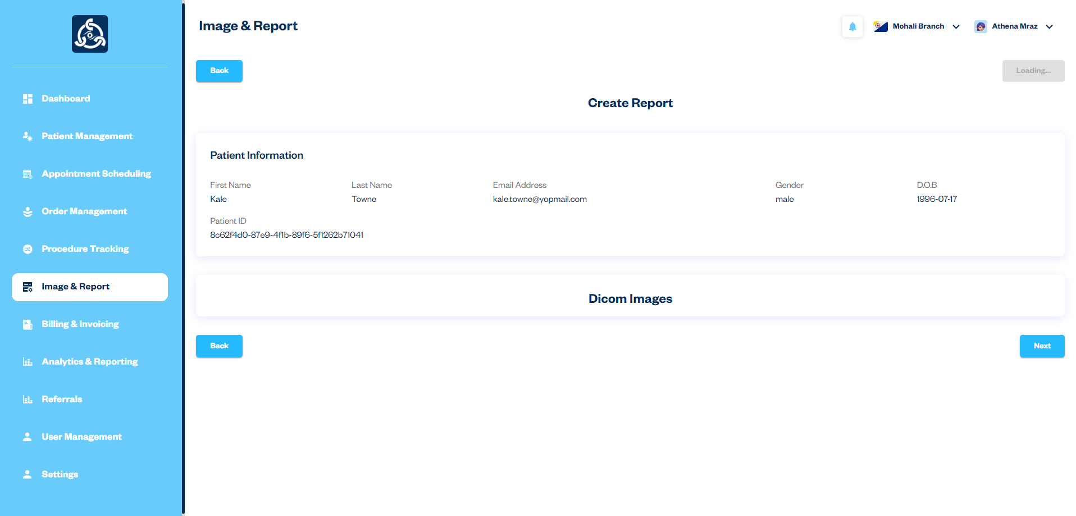

8. Billing & Invoicing

Managing Bills and Invoices

Description: The Billing & Invoicing module enables the Superadmin to effectively manage and generate bills and invoices for patients. This module includes functionality for creating invoices from orders, viewing existing invoices, and handling both billed and unbilled invoices.

Workflow:

1. The Superadmin accesses the "Billing & Invoicing" module from the side navigation.
2. A list of all invoices is displayed, showing detailed information and options to manage each invoice.
3. To generate a new invoice, the Superadmin clicks the "Generate Invoice" button.
4. The Superadmin selects an order from the list for which the invoice is to be generated.
5. The selected order triggers the display of the invoice form, where the Superadmin fills out the necessary billing details.
6. The invoice is generated and added to the Invoice List.
7. To update an existing invoice, the Superadmin clicks the "Update Invoice" button, makes the necessary changes, and saves the updates.
8. To print or download an invoice, the Superadmin clicks the "Print Invoice" button to generate a PDF.
9. To send an invoice via email, the Superadmin clicks the "Send Email" button, which opens a popup for entering the recipient's email address. The invoice is then sent to that address.
10. The Superadmin can manage invoices by choosing between "Billed" and "Unbilled" options, depending on their status.

Unbilled Invoices

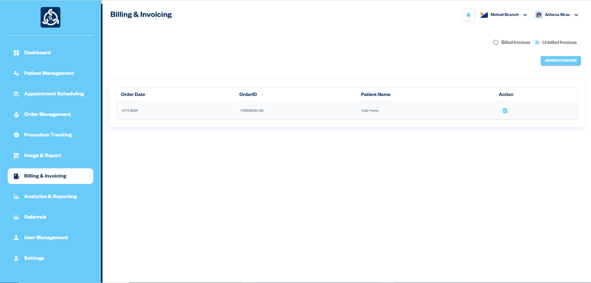

Billed Invoices

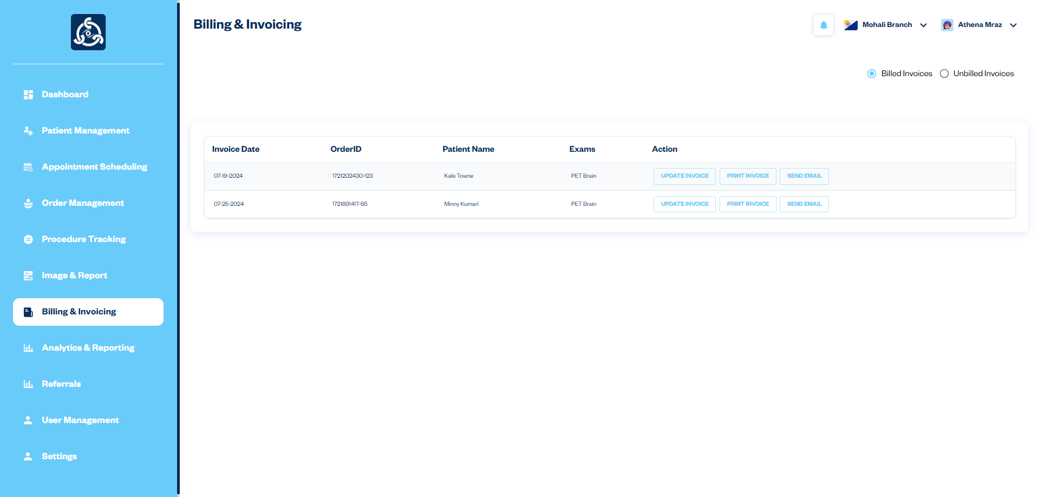

Generate Invoice Form

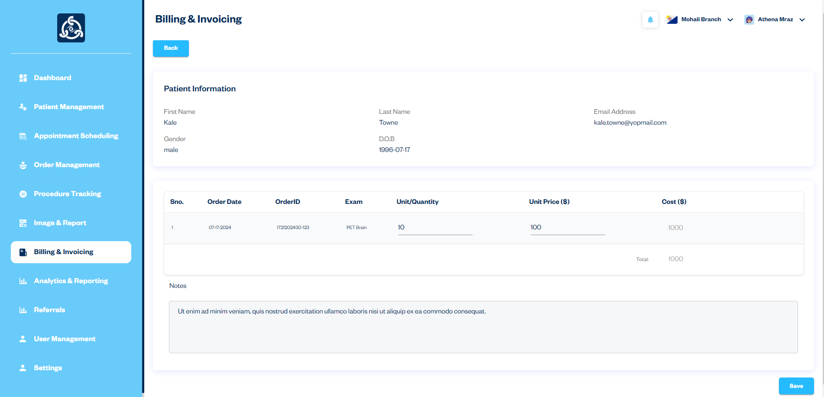

9. Analytics & Reporting

Managing Analytics & Reporting

Description**:** The Analytics & Reporting module is designed to provide a comprehensive and detailed analysis of various metrics within the VOXXIL RIS web app. It offers insights into the operational aspects of the healthcare system by presenting data in an easy-to-understand format through various cards. This module helps healthcare providers and administrators to monitor performance, identify trends, and make informed decisions based on the data.

Key Features:

1. Completed Reports:
   * Displays the total number of reports that have been finalized and completed.
   * Action: Click the "View All" button to see a detailed list of completed reports in the Image & Report section.
2. Modified Reports:
   * Shows the number of reports that have been modified after their initial completion.
   * Action: Click the "View All" button to see a detailed list of modified reports in the Image & Report section.
3. Incompleted Reports:
   * Indicates the count of reports that are still pending or in progress.
   * Action: Click the "View All" button to see a detailed list of incompleted reports in the Image & Report section.
4. Cancelled Appointments**:**
   * Displays the total number of appointments that have been cancelled.
   * Action: Click the "View All" button to see a detailed list of cancelled appointments in the Order Management section.
5. Top 5 Taken Exams:
   * Lists the top five exams that are most frequently conducted within the healthcare facility.
   * The listing of the top five exams is shown on the card.

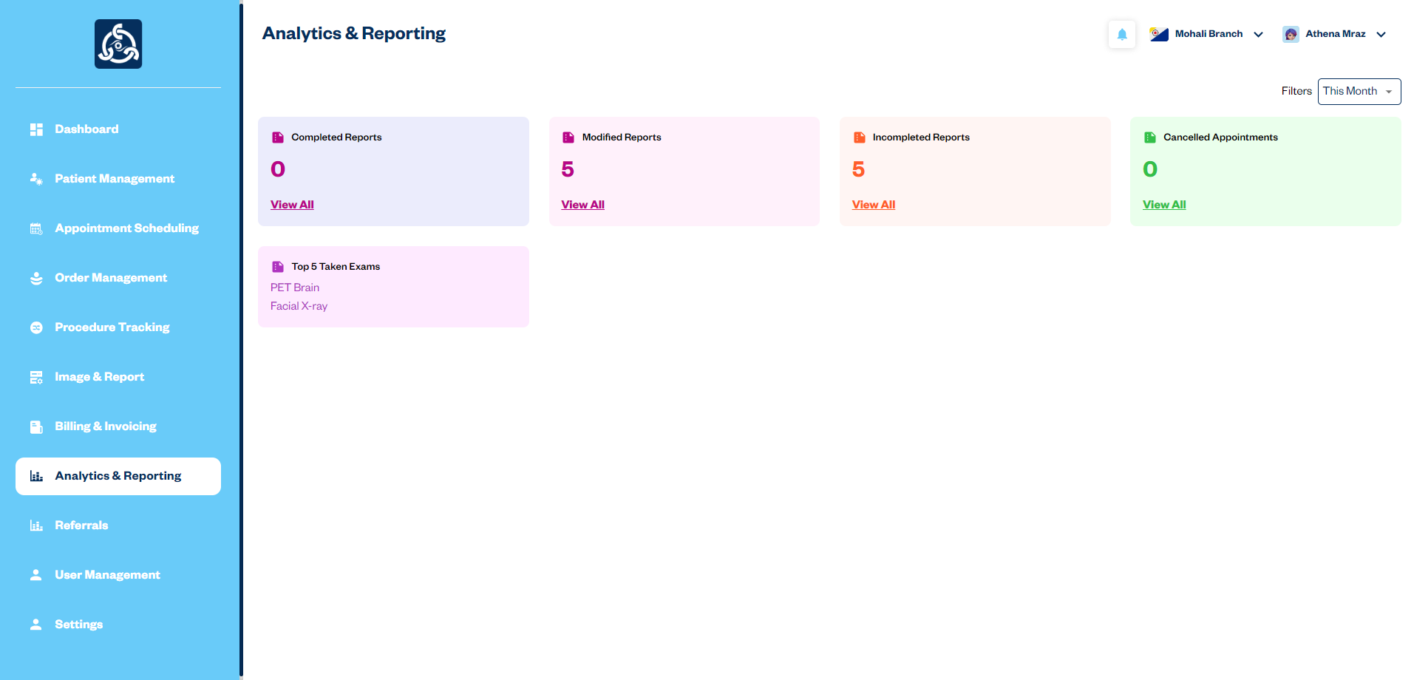

### 10. Referrals

#### Managing Patient Referrals

**Description:** The Referrals module enables the Superadmin to manage and track patient referrals across different branches within the healthcare system. This module facilitates the process of referring patients from one branch to another, ensuring efficient and coordinated care across various locations. This module includes functionality for viewing referral details, processing referrals, and tracking their status to ensure that patients receive timely care and follow-up.

Workflow:

1. The Superadmin accesses the "Referrals" module from the side navigation.
2. A list of all patient referrals is displayed, including details such as the destination branch and status.
3. The Superadmin can filter referrals by selecting from three categories: Incoming, Outgoing, and Declined Orders.
4. To add a new referral, the Superadmin clicks the "Add Referral" button and fills in the necessary details, selecting the appropriate destination branch.
5. To accept or deny a referral, the Superadmin clicks the "Accept Order" or "Deny Order" button, updating the referral status accordingly.
6. When forwarding a referral to another branch, the Superadmin selects the destination branch from a list of available branches.

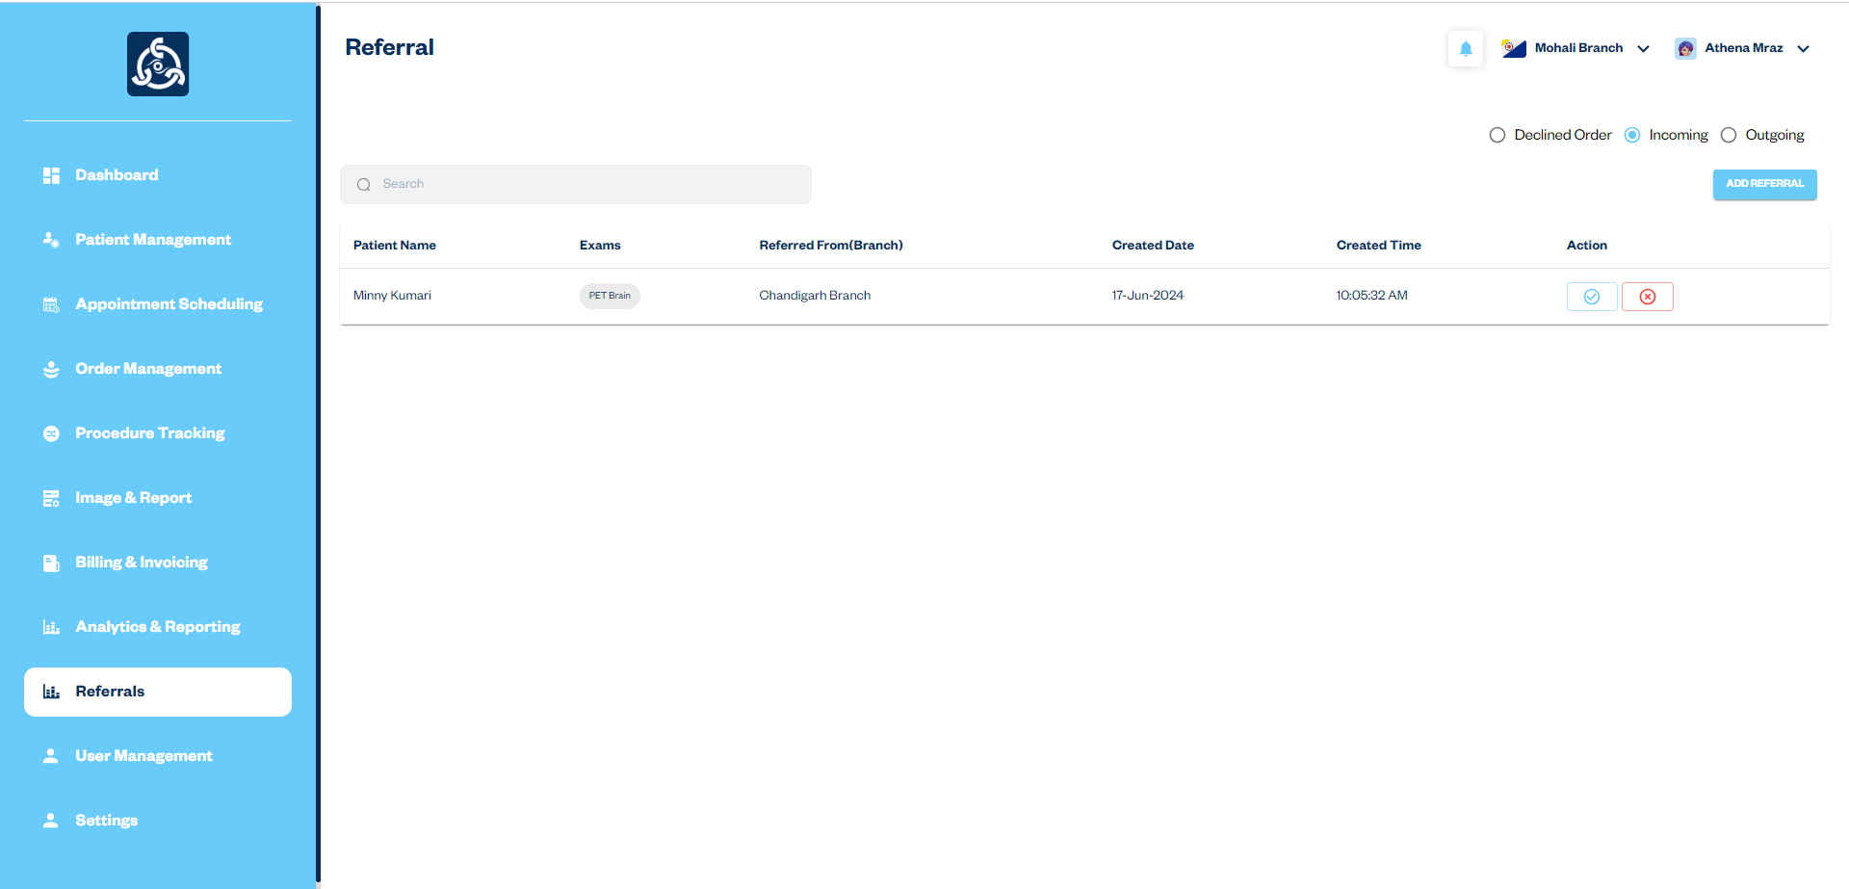

Add Referral Form

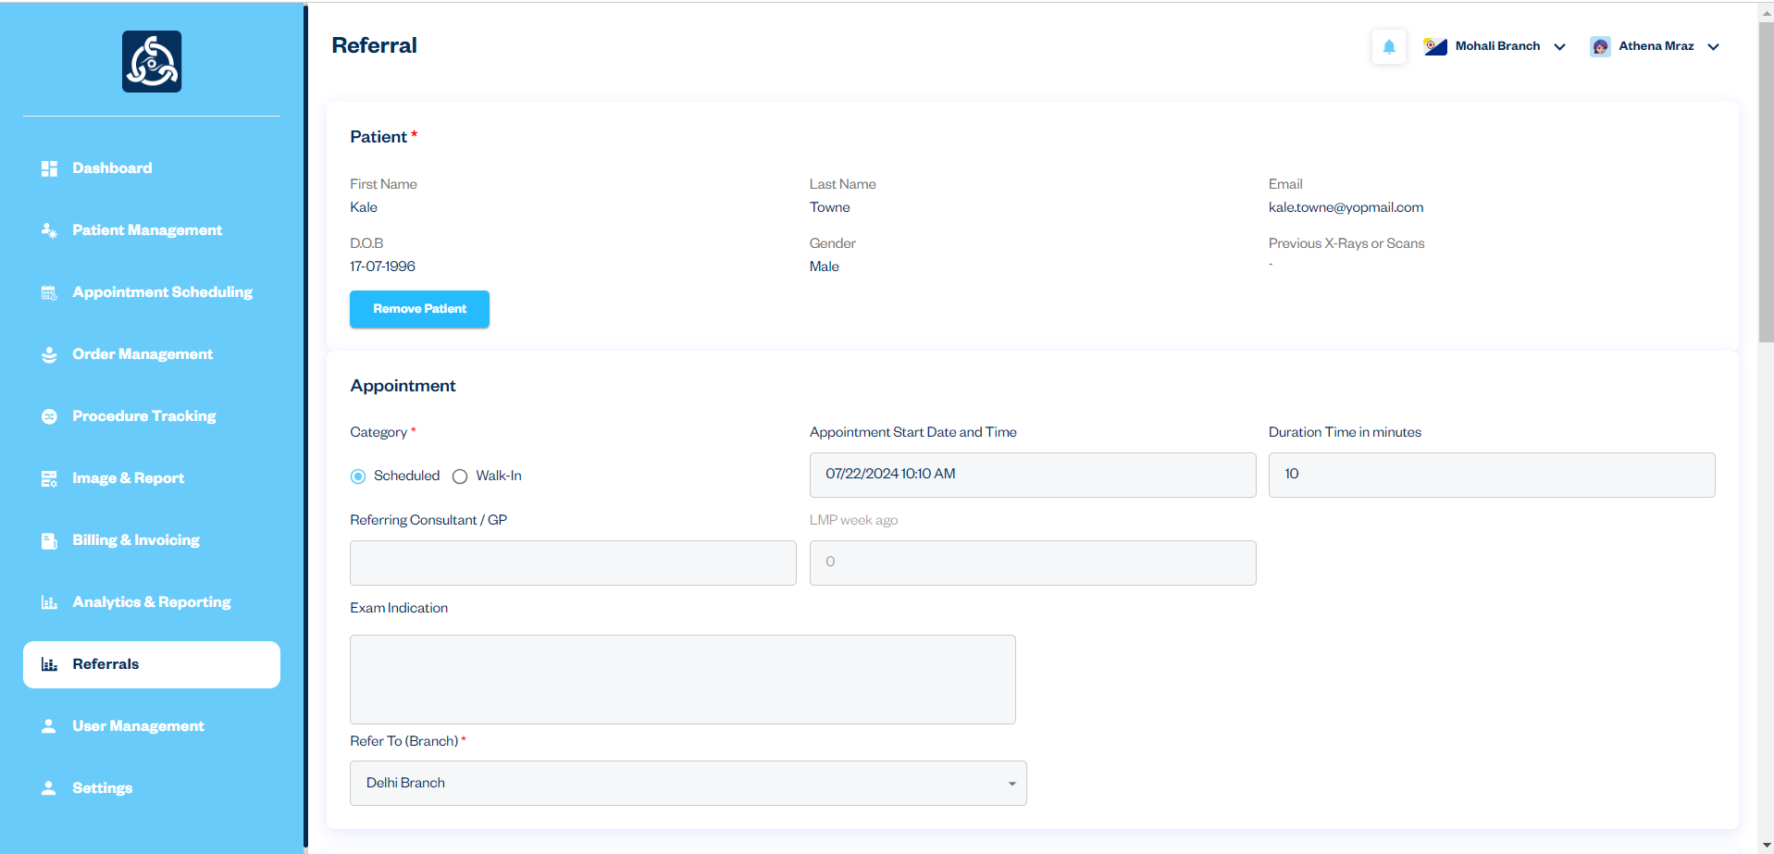

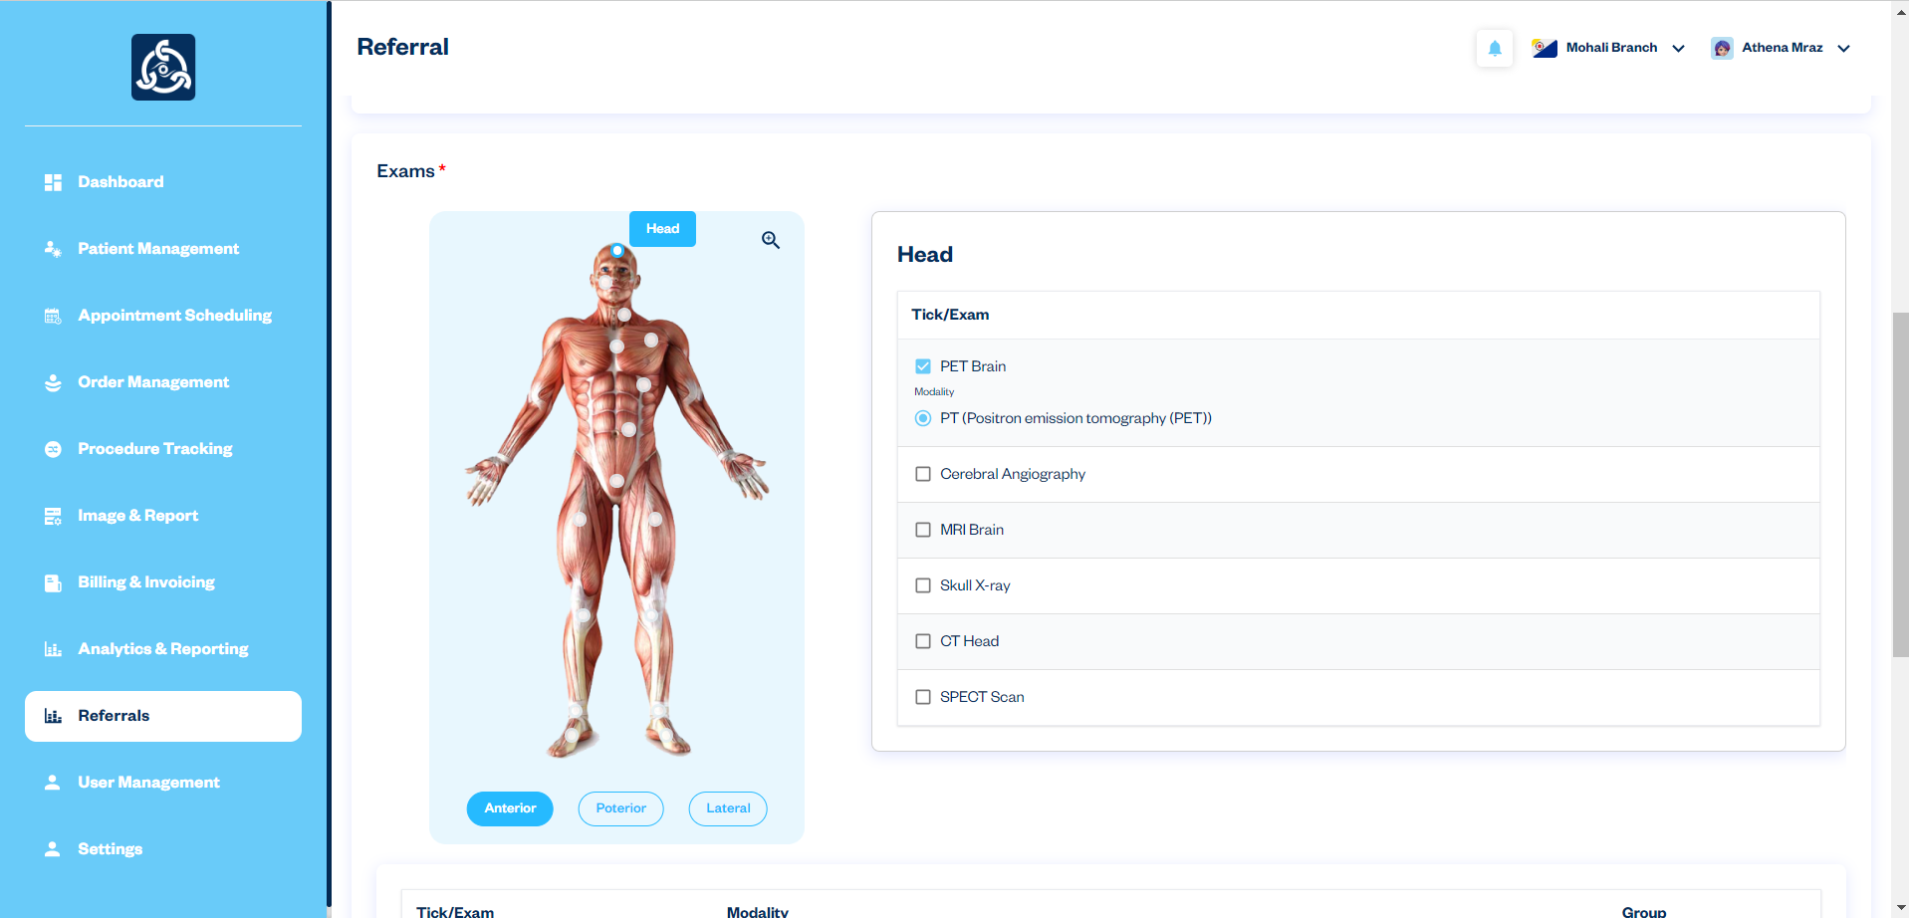

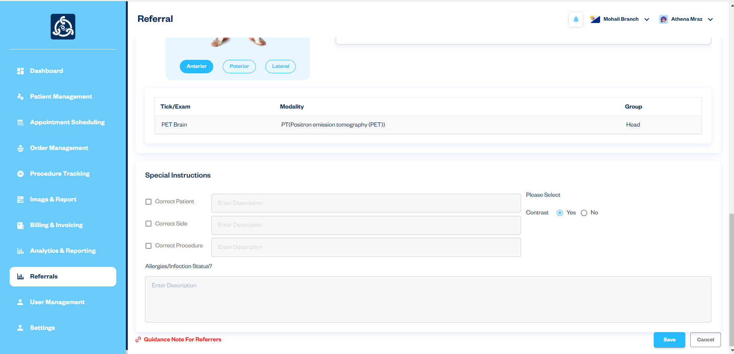

### 11. User Management

#### Managing Users and Access

**Description**: The User Management module allows the Superadmin to manage user accounts and access levels within the healthcare system. This module ensures that each user has the appropriate permissions and access to perform their duties effectively, contributing to the overall security and efficiency of the system.

Workflow:

1. The Superadmin accesses the "User Management" module from the side navigation.
2. A list of all users is displayed, showing details such as name, email, and role, with action buttons for editing or deleting users.
3. To add a new user, the Superadmin clicks the "+Add" button and fills in the necessary details, including name, email, password, and role.
4. To edit an existing user, the Superadmin selects the user from the list and clicks the "Edit Icon" to update information or change roles and permissions.
5. To delete a user, the Superadmin clicks the "Delete Icon" for removing their account from the system.

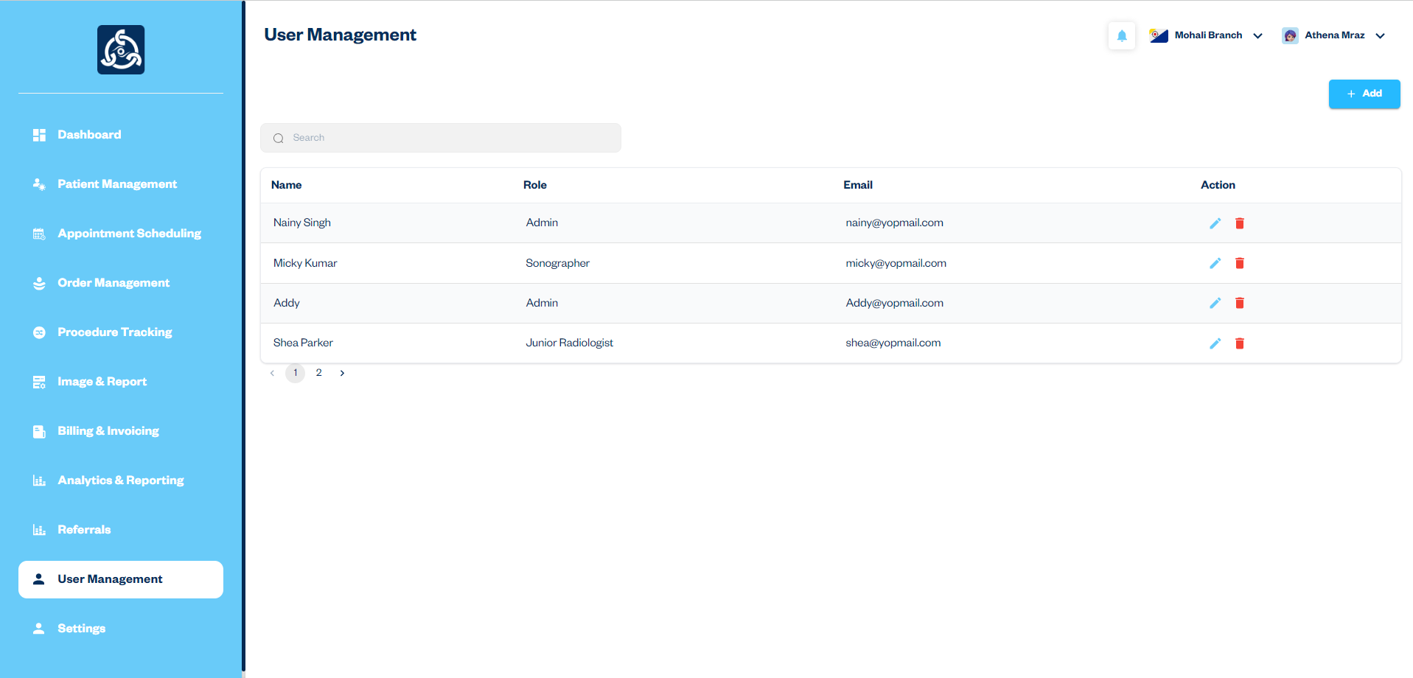

Add User Form

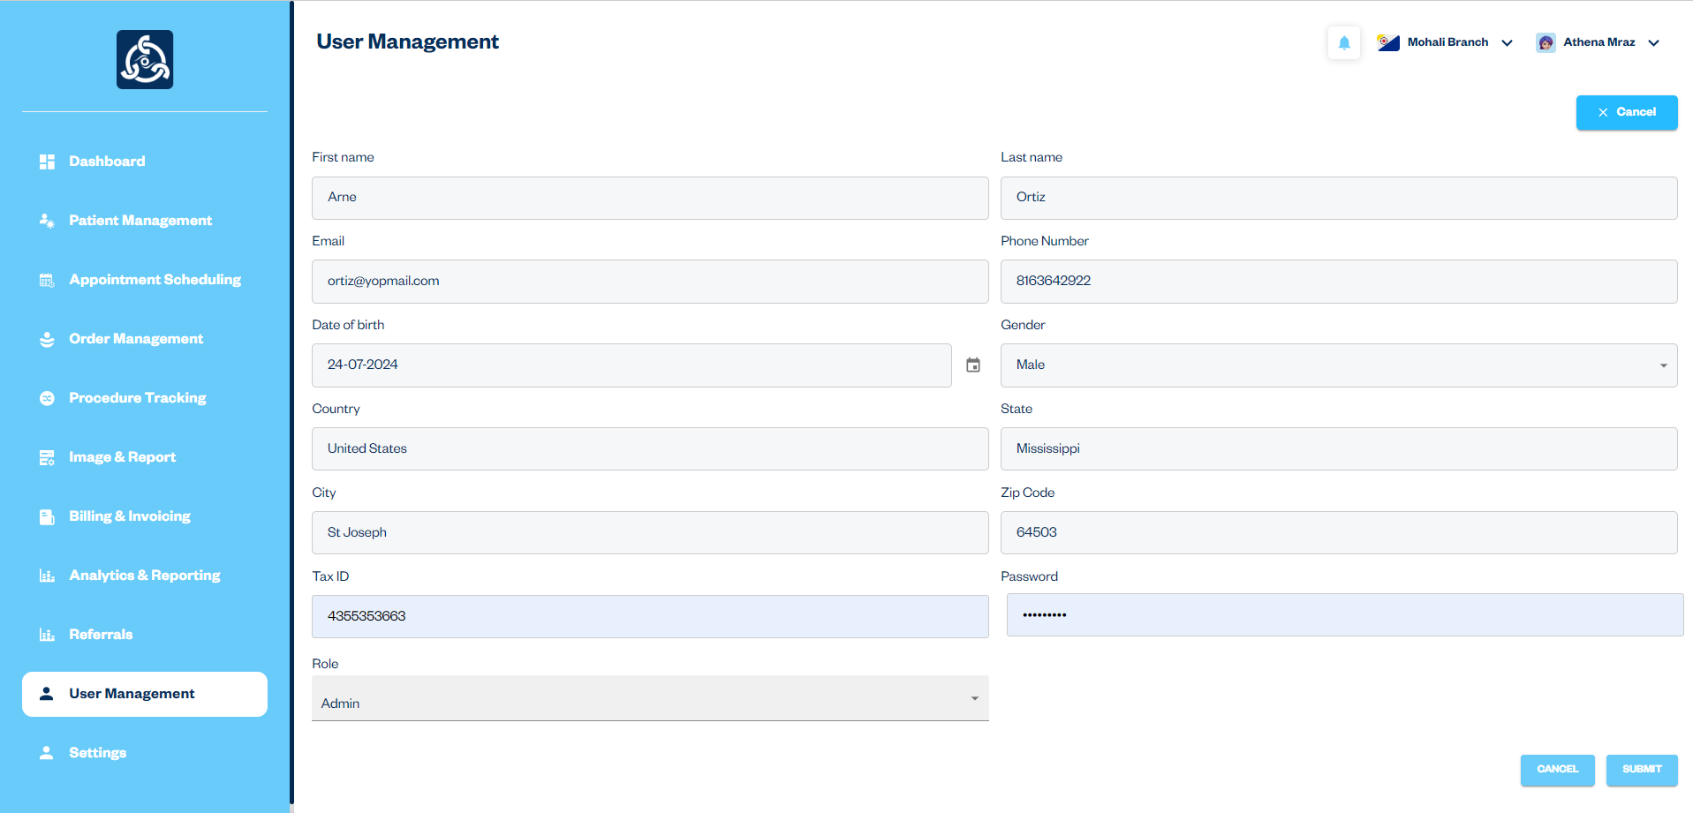

12. Settings

Description: The Settings module provides comprehensive options for managing various aspects of the healthcare system, including branches, exams list, exams group, and modality list. This module ensures that all necessary configurations and administrative tasks can be performed efficiently, allowing for streamlined operations within the system.

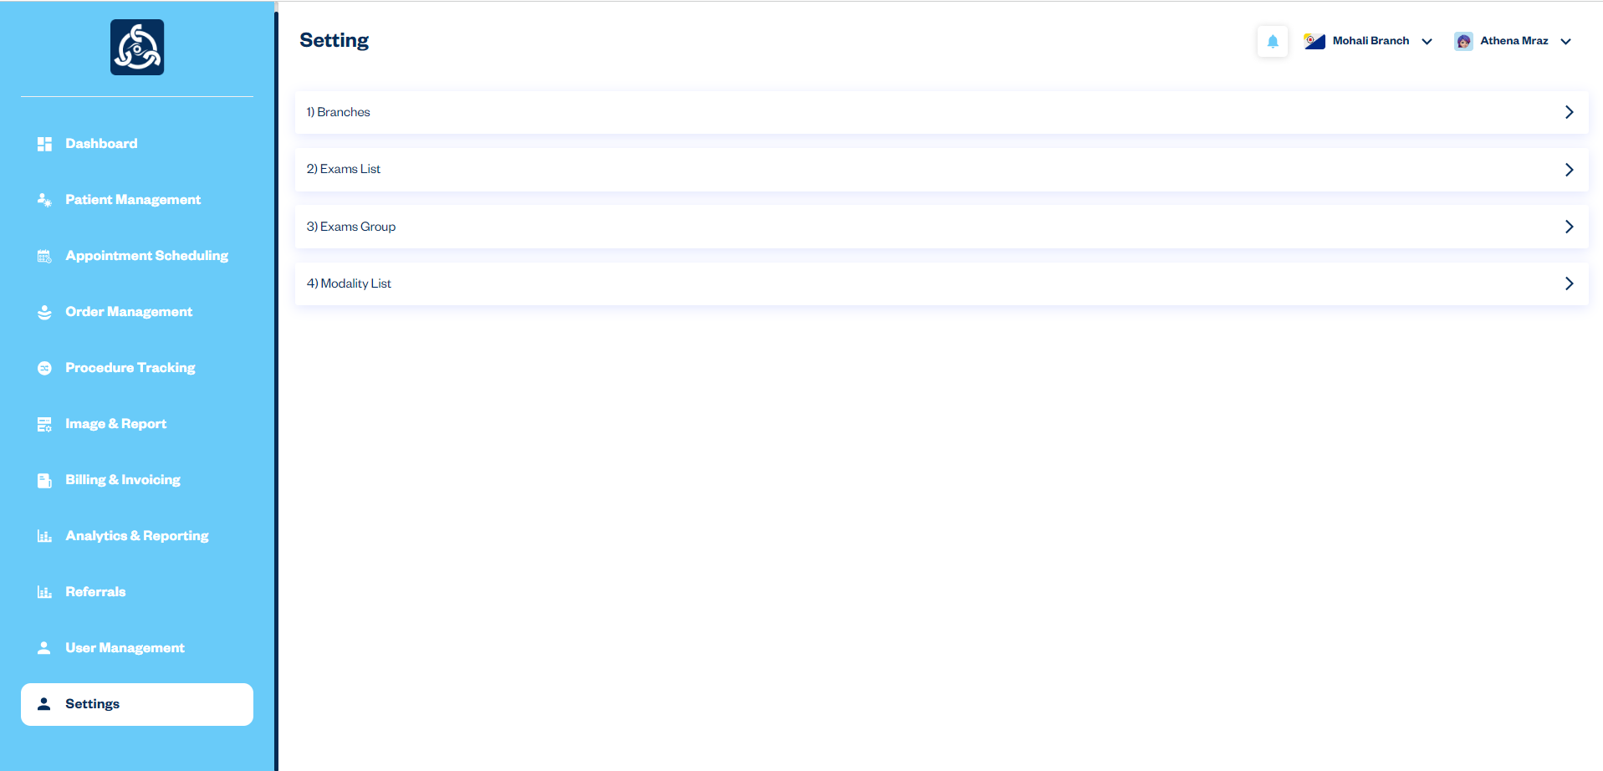

Workflow:

1. Branches:
   * Access the "Branches" section from the Settings module.
   * View the list of existing branches.
   * To add a new branch, click the "+Add" button.
   * Fill out the "Add Branch" form with the necessary details and click "Submit" to add the branch.
   * To update branch details, click the edit icon in the listing, make the necessary changes in the form, and click "Update" to save the updates.
   * To delete a branch, click the delete icon in the listing and confirm the deletion.

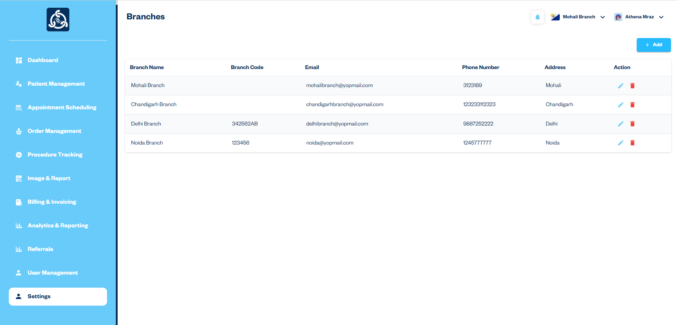

Add Branch Form

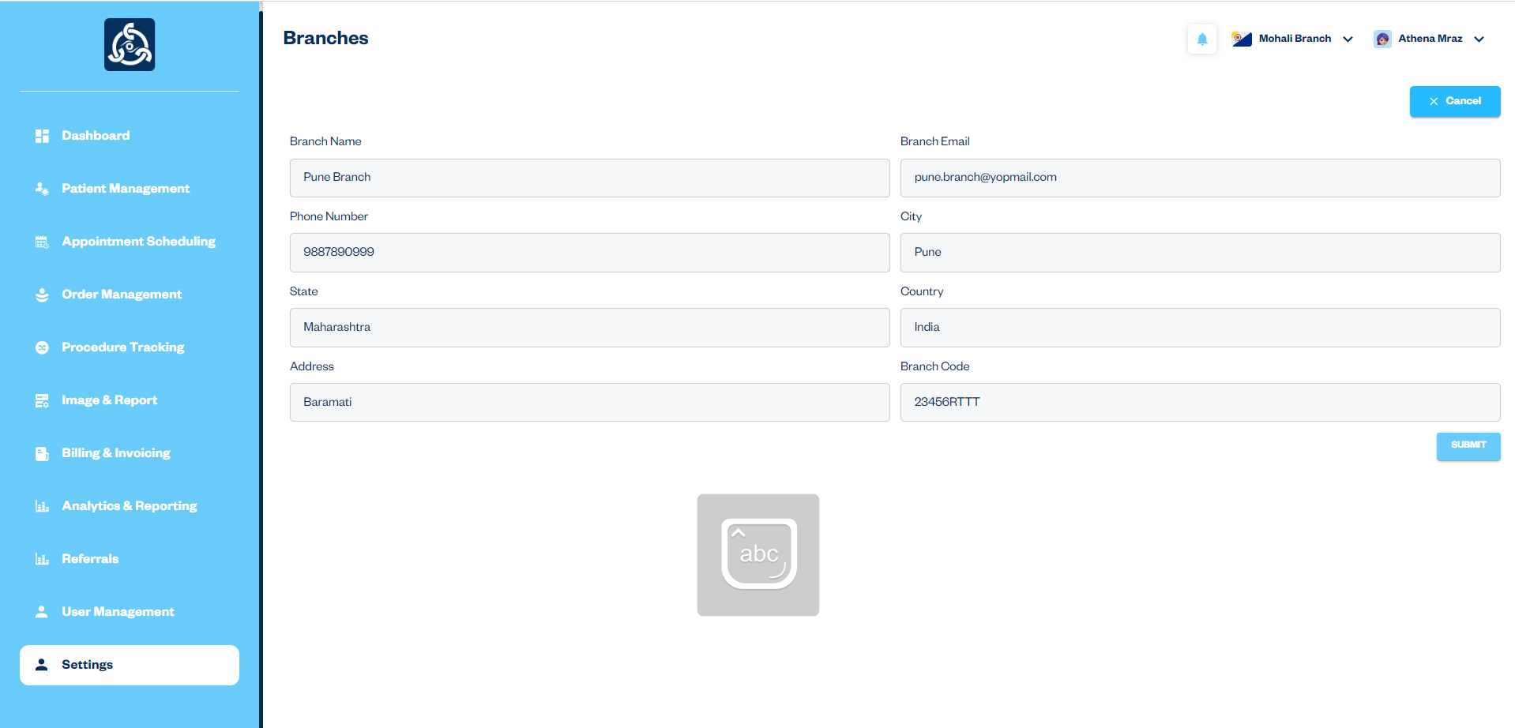

1. Exam List:
   * Access the "Exam List" section from the Settings module.
   * View the list of existing exams.
   * To add a new exam, click the "+Add" button.
   * Fill out the "Exam List" form with the exam name and modality, then click "Submit" to add the exam.
   * To update exam details, click the edit icon in the listing, make the necessary changes in the form, and click "Update" to save the updates.
   * To delete an exam, click the delete icon in the listing and confirm the deletion.

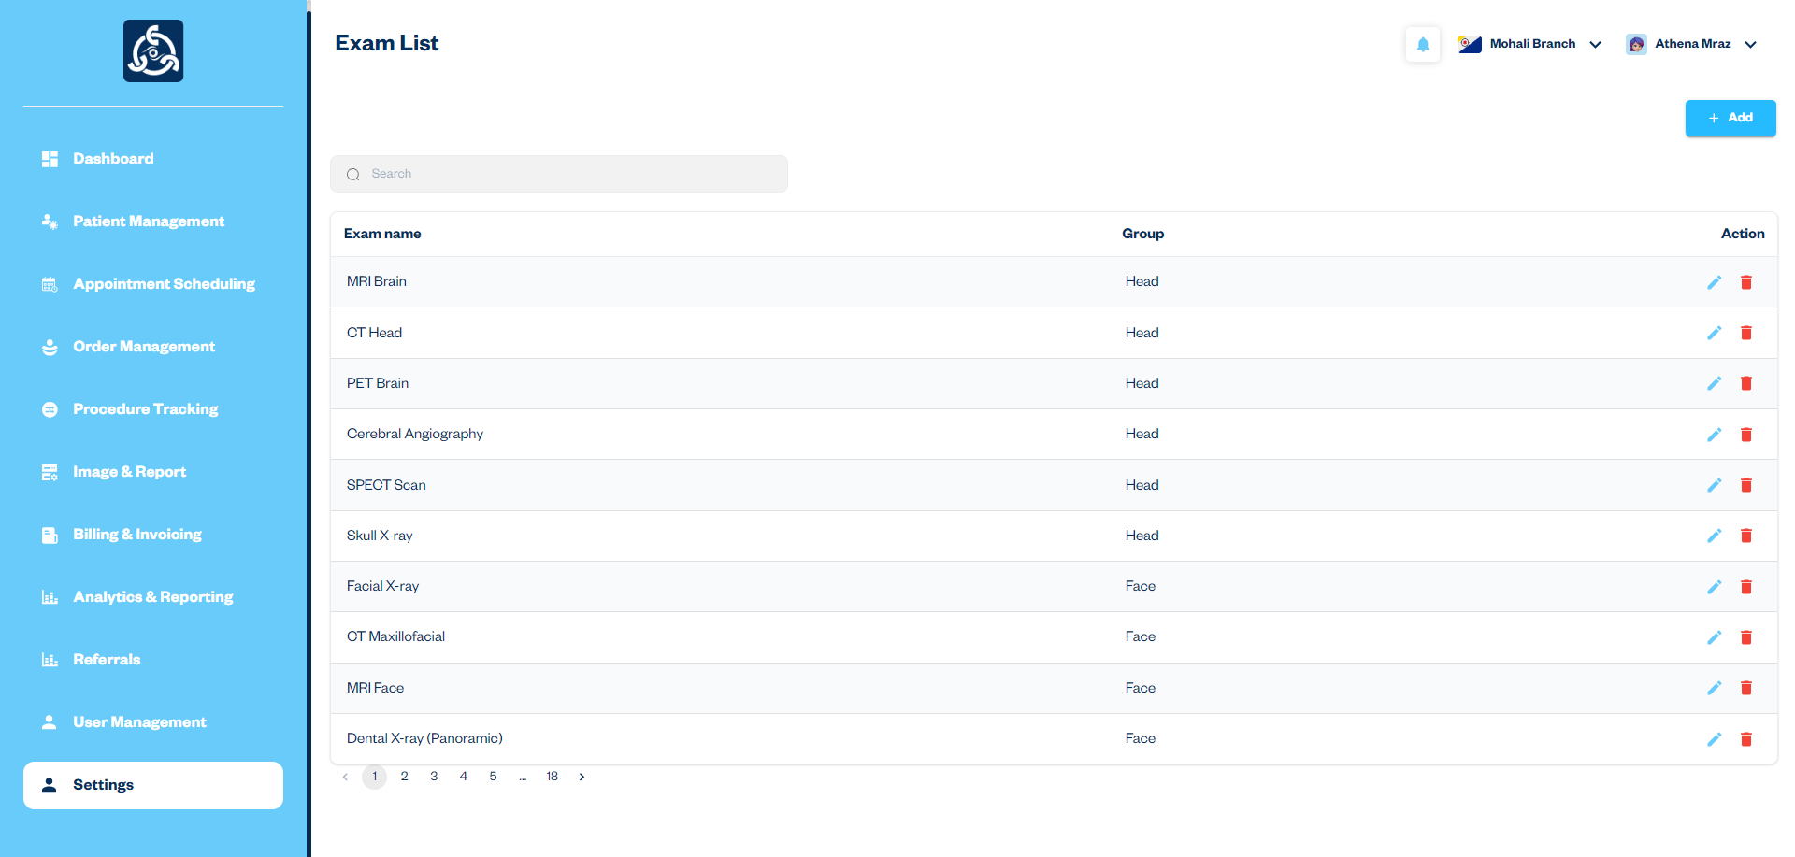

Add Exam List Form

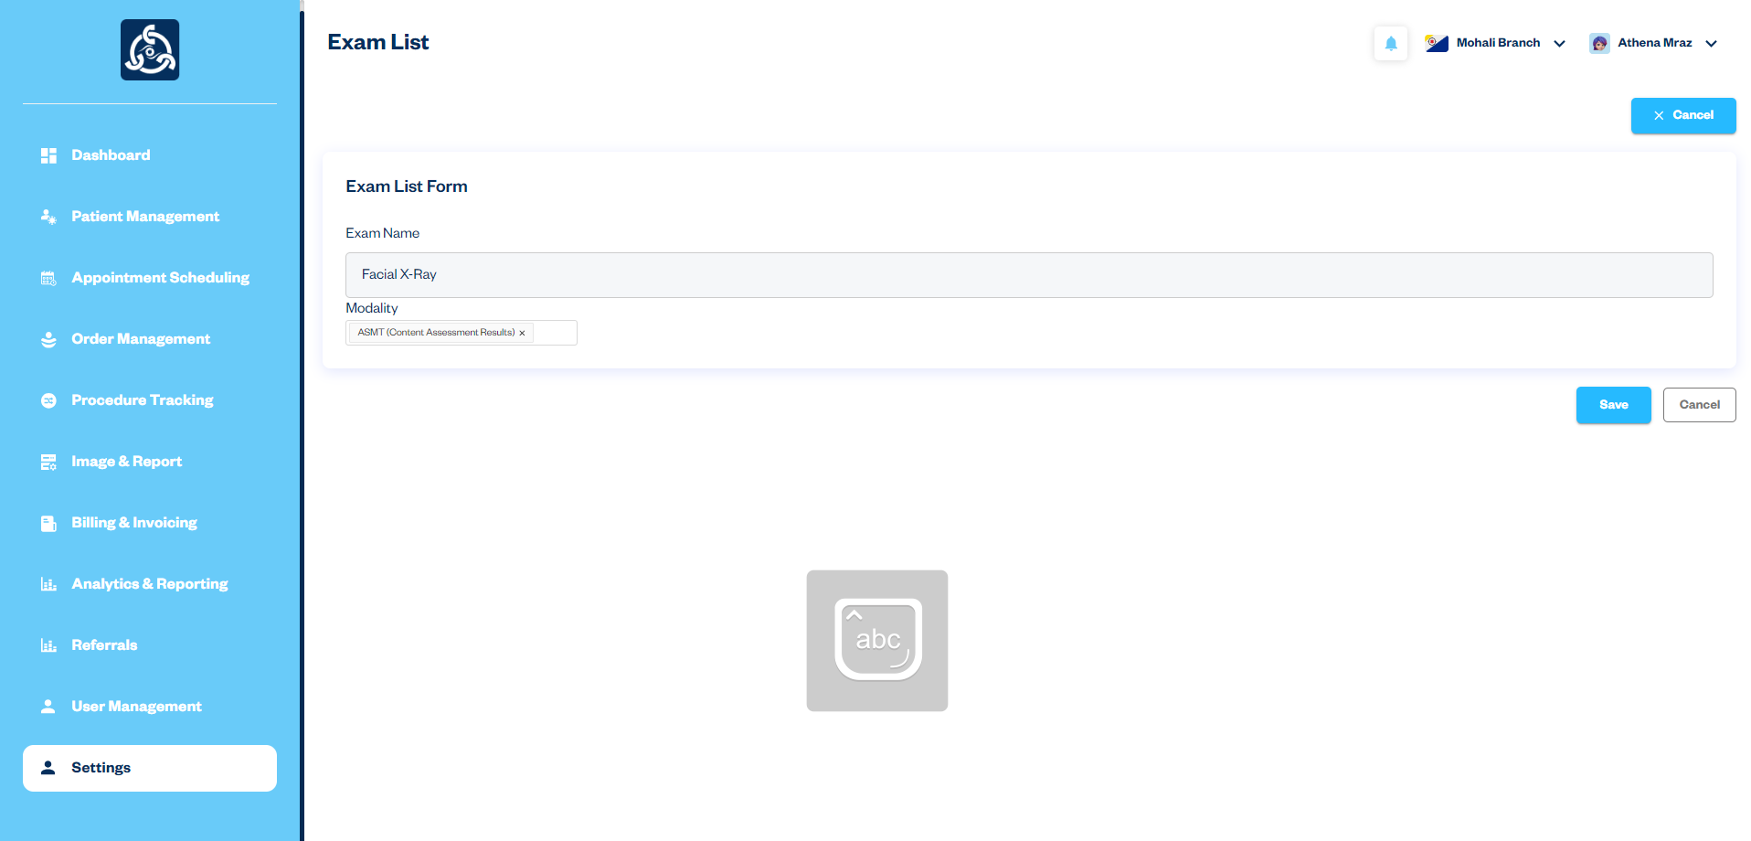

1. Exam Groups:
   * Access the "Exam Groups" section from the Settings module.
   * View the list of existing exam groups.
   * To add a new exam group, click the "+Add" button.
   * Fill out the "Exam Group" form with the exam group name and select relevant exams, then click "Submit" to add the group.
   * To update exam group details, click the edit icon in the listing, make the necessary changes in the form, and click "Update" to save the updates.
   * To delete an exam group, click the delete icon in the listing and confirm the deletion.

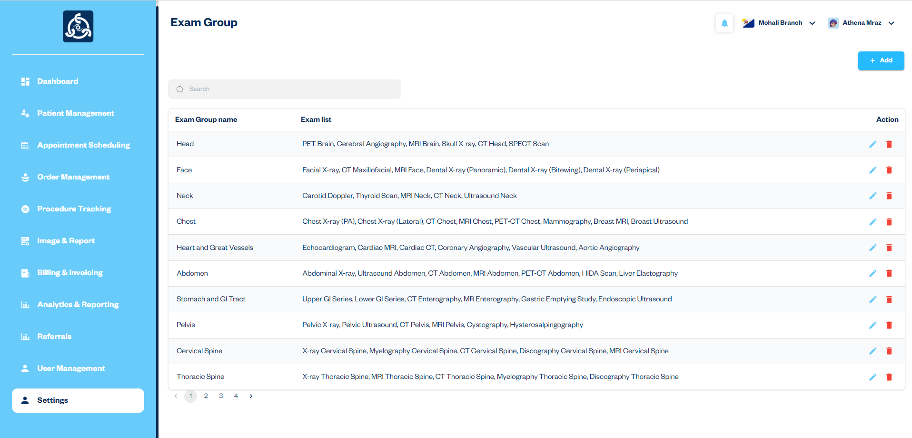

Add Exam Group Form

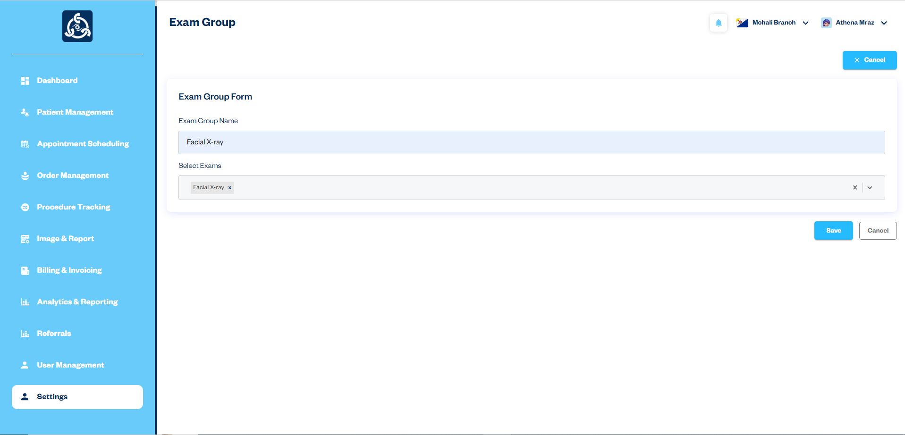

1. Modality List:
   * Access the "Modality List" section from the Settings module.
   * View the list of existing modalities.
   * To add a new modality, click the "+Add" button.
   * Fill out the "Modality List" form with the modality name and description, then click "Submit" to add the modality.
   * To update modality details, click the edit icon in the listing, make the necessary changes in the form, and click "Update" to save the updates.
   * To delete a modality, click the delete icon in the listing and confirm the deletion.

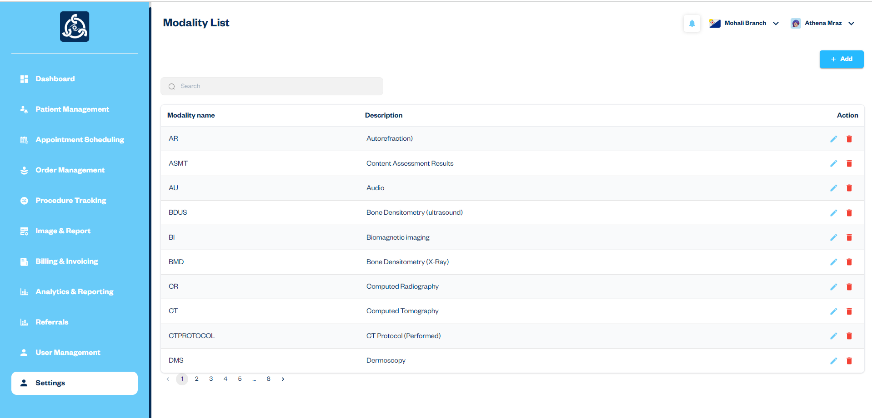

Add Modality List Form

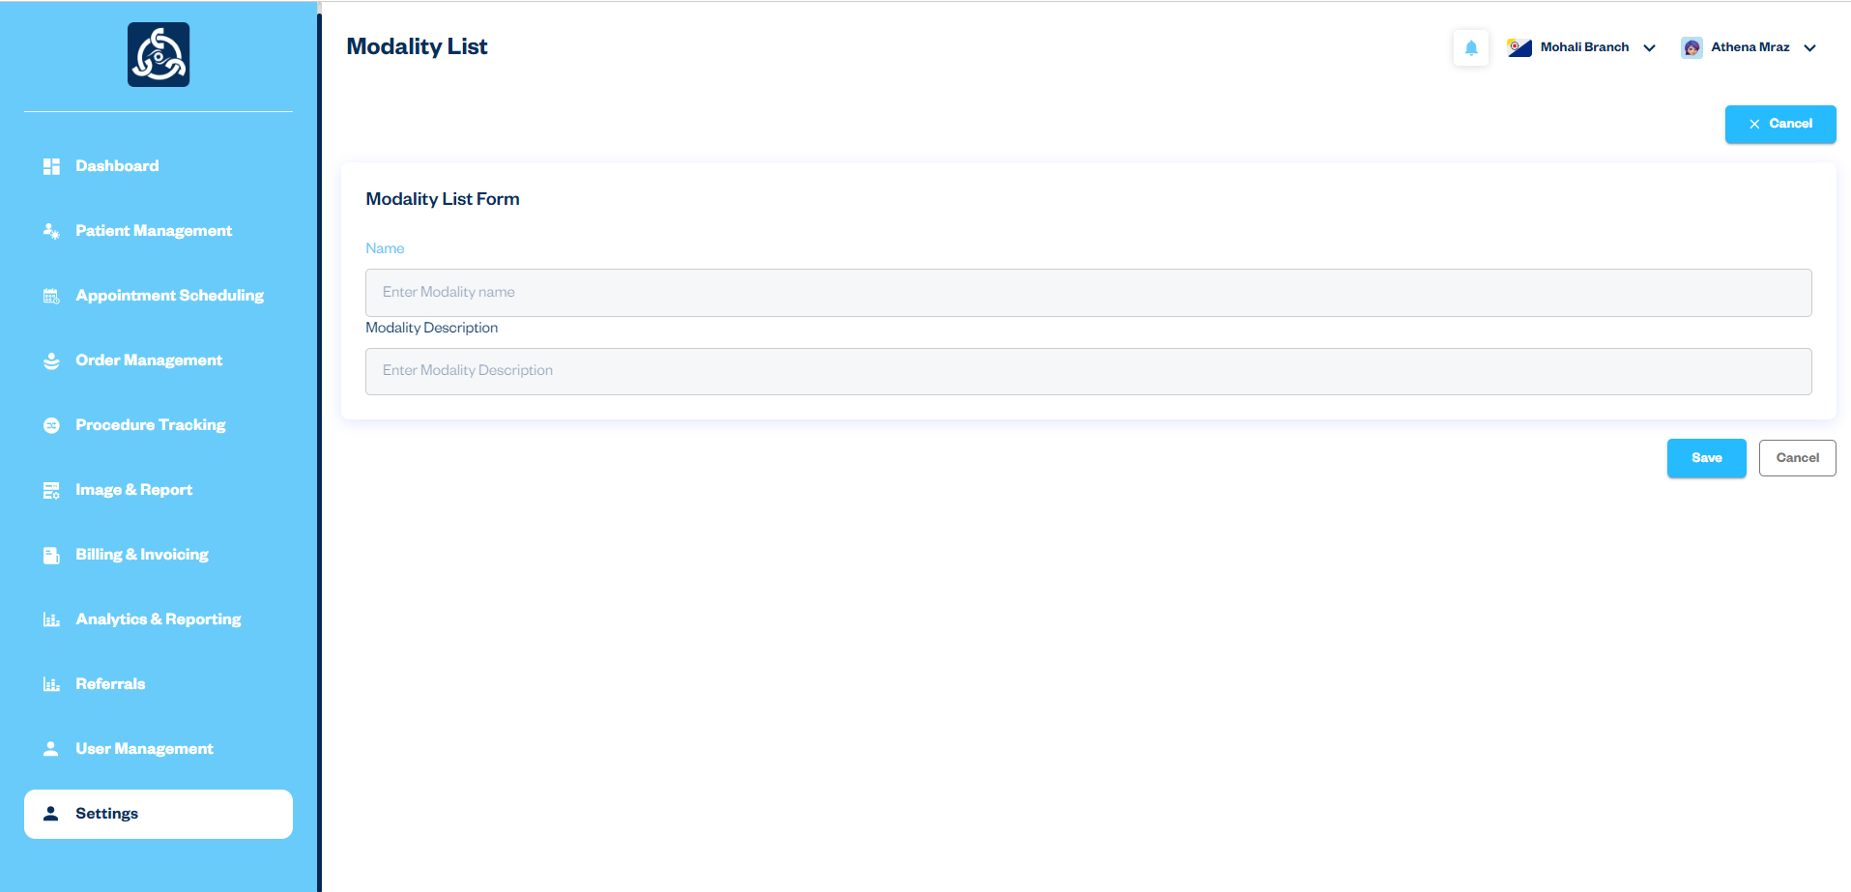

Header Profile Picture Dropdown

Description: The header contains a profile picture with a dropdown menu that provides quick access to profile editing, settings, and logout options. This functionality enhances user experience by offering easy navigation to essential actions.

Workflow:

1. Dropdown Options:
   * The profile picture in the header has a dropdown menu that opens upon clicking.
   * The dropdown menu includes three options:
     1. Edit Profile
     2. Settings
     3. Logout
2. Edit Profile:
   * Click on the "Edit Profile" option in the dropdown menu.
   * You will be redirected to the "Edit Profile" page where you can update your profile information.
   * On the "Edit Profile" page, you can also change your password by filling out the "Change Password" form and submitting the updated details.

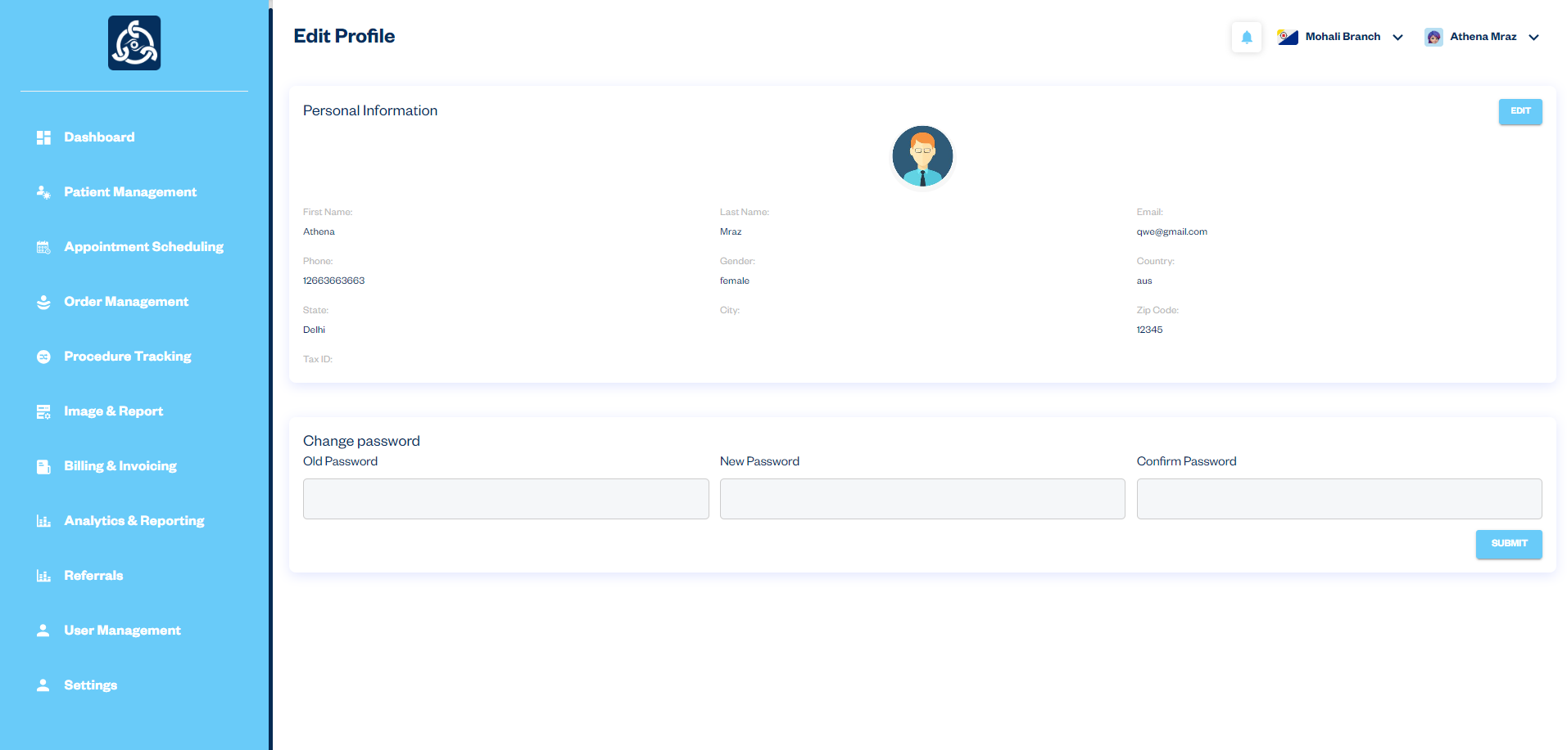

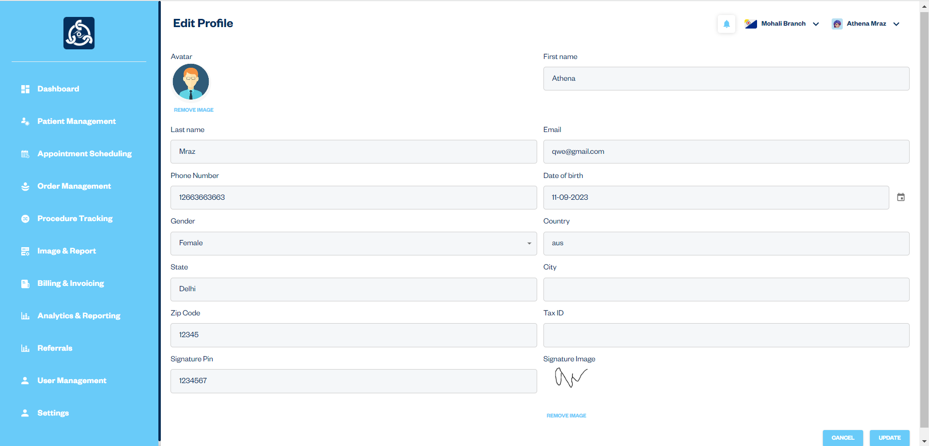

1. Settings:
   * Click on the "Settings" option in the dropdown menu.
   * You will be redirected to the "Settings" section where you can manage various configurations and administrative tasks.
2. Logout:
   * Click on the "Logout" option in the dropdown menu.
   * You will be logged out of the system and redirected to the login page.

Admin Module

Introduction**:**

The Admin module is designed to provide administrative capabilities similar to the Superadmin module, with a few key differences. Each branch has its own dedicated Admin who can access and manage all modules related to their specific branch. Additionally, Admins can view referrals from other branches directed to their branch.

Key Features:

1. Branch-Specific Access**:**
   * Each branch is assigned a dedicated Admin.
   * The Admin can access and manage all modules and data related only to their specific branch.
2. Module Access:
   * The Admin module includes access to the following modules:
     + Patient Management**:** Manage patient information and records within the branch.
     + Appointment Scheduling**:** Schedule and manage appointments for patients in the branch.
     + Order Management**:** View, create, edit, delete, and manage orders and appointments specific to the branch.
     + Procedure Tracking**:** Track procedures for orders within the branch.
     + Image and Report**:** View procedures and create reports for the branch.
     + Billing & Invoicing**:** Manage and generate bills and invoices for patients in the branch.
     + Referrals**:** Manage referrals from other branches to the Admin's branch.
     + User Management**:** Manage users within the branch, including adding, editing, and deleting user accounts.
     + Settings**:** Configure settings related to the branch, including branch details, exams list, exam groups, and modality list.
3. Referrals:
   * Admins can view referrals from other branches that are directed to their branch.
   * Admins can accept or deny these referrals, ensuring proper management of referred patients.

Patient Module

**Introduction:**

The Patient module is a crucial component of the VOXXIL RIS web app, designed to manage all aspects of patient information and interactions. It provides a comprehensive and centralized platform for handling patient records, appointments, medical histories. This module ensures that healthcare providers have easy access to accurate and up-to-date patient information, facilitating better patient care and streamlined administrative processes.

1. Patient Module Dashboard

Description**:** The Patient Module Dashboard in the VOXXIL RIS web app is designed to provide healthcare providers with a clear and organized view of patient appointments. It offers easy access to listings for today's appointments, past appointments, and upcoming appointments, facilitating efficient management and scheduling.

Key Features:

1. Today's Appointments:
   * Listing Overview: View a detailed list of all patient appointments scheduled for the current day.
   * Details: Each appointment entry includes branch name, appointment time, location, and any specific notes or instructions.
2. Upcoming Appointments:
   * Listing Overview**:** Access a summary of all appointments scheduled for future dates beyond today.
   * Details**:** The list includes date, time, branch names, and appointment types.
3. Past Appointments:
   * Listing Overview**:** Review a comprehensive list of all completed appointments.
   * Details: Information includes branch name, appointment dates, and outcomes or notes from each visit.

Workflow:

1. Accessing the Dashboard:
   * Log in to the VOXXIL RIS web app and navigate to the Patient module dashboard from the side navigation menu.
2. Viewing Today's Appointments:
   * Navigate to the "Today's Appointments" section to see a list of appointments for the current day.
3. Checking Upcoming Appointments:
   * Go to the "Upcoming Appointments" section to view all future appointments.
   * Review the list to prepare for upcoming patient visits.
4. Reviewing Past Appointments:
   * Access the "Past Appointments" section to view a record of all completed appointments.

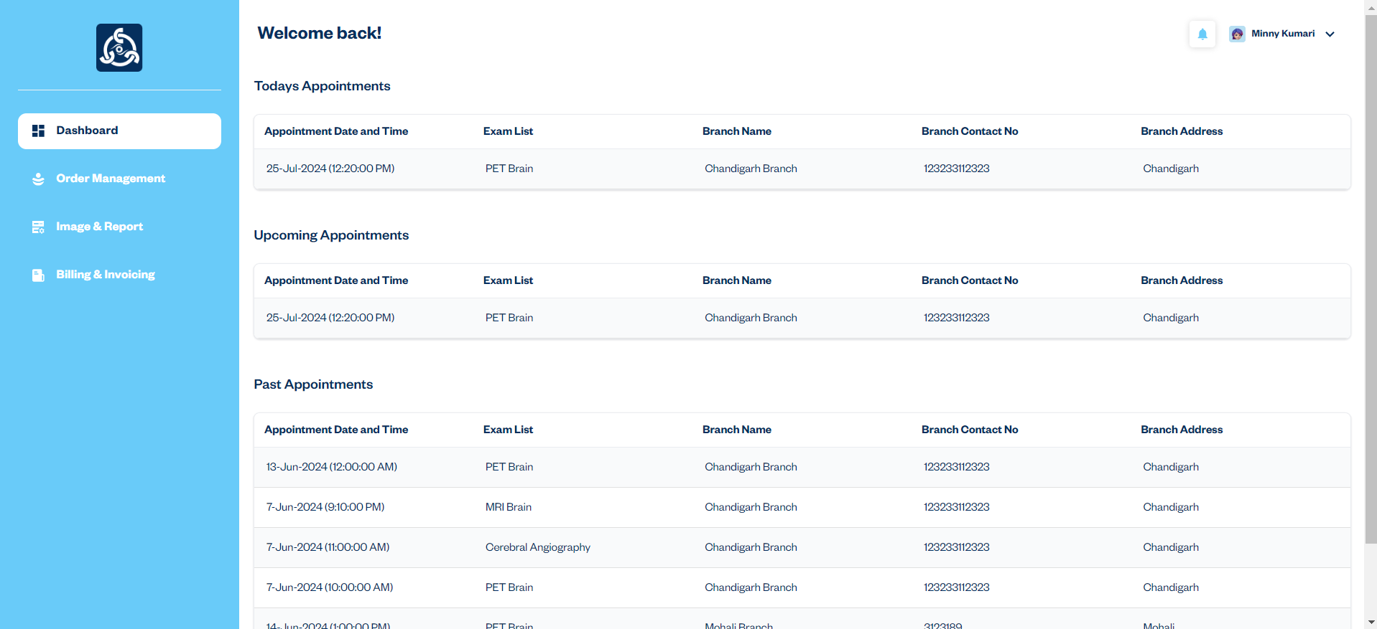

2. Order Management:

**Description:** The Order Management Module in the VOXXIL RIS web app is designed to streamline the handling of patient orders. It provides users with the ability to view a list of patient orders and access detailed information for specific orders. This module ensures efficient tracking and management of orders, enhancing the overall workflow within the healthcare system.

Workflow:

1. The user accesses the Order Management module from the side navigation menu.

2. A comprehensive list of all patient orders is displayed, showing key details such as order ID, appointment date & time, and exams.

3. To view detailed information about a specific order, the user clicks the view icon next to the corresponding order in the listing.

4. The detailed view provides information about the selected order, including examination content.

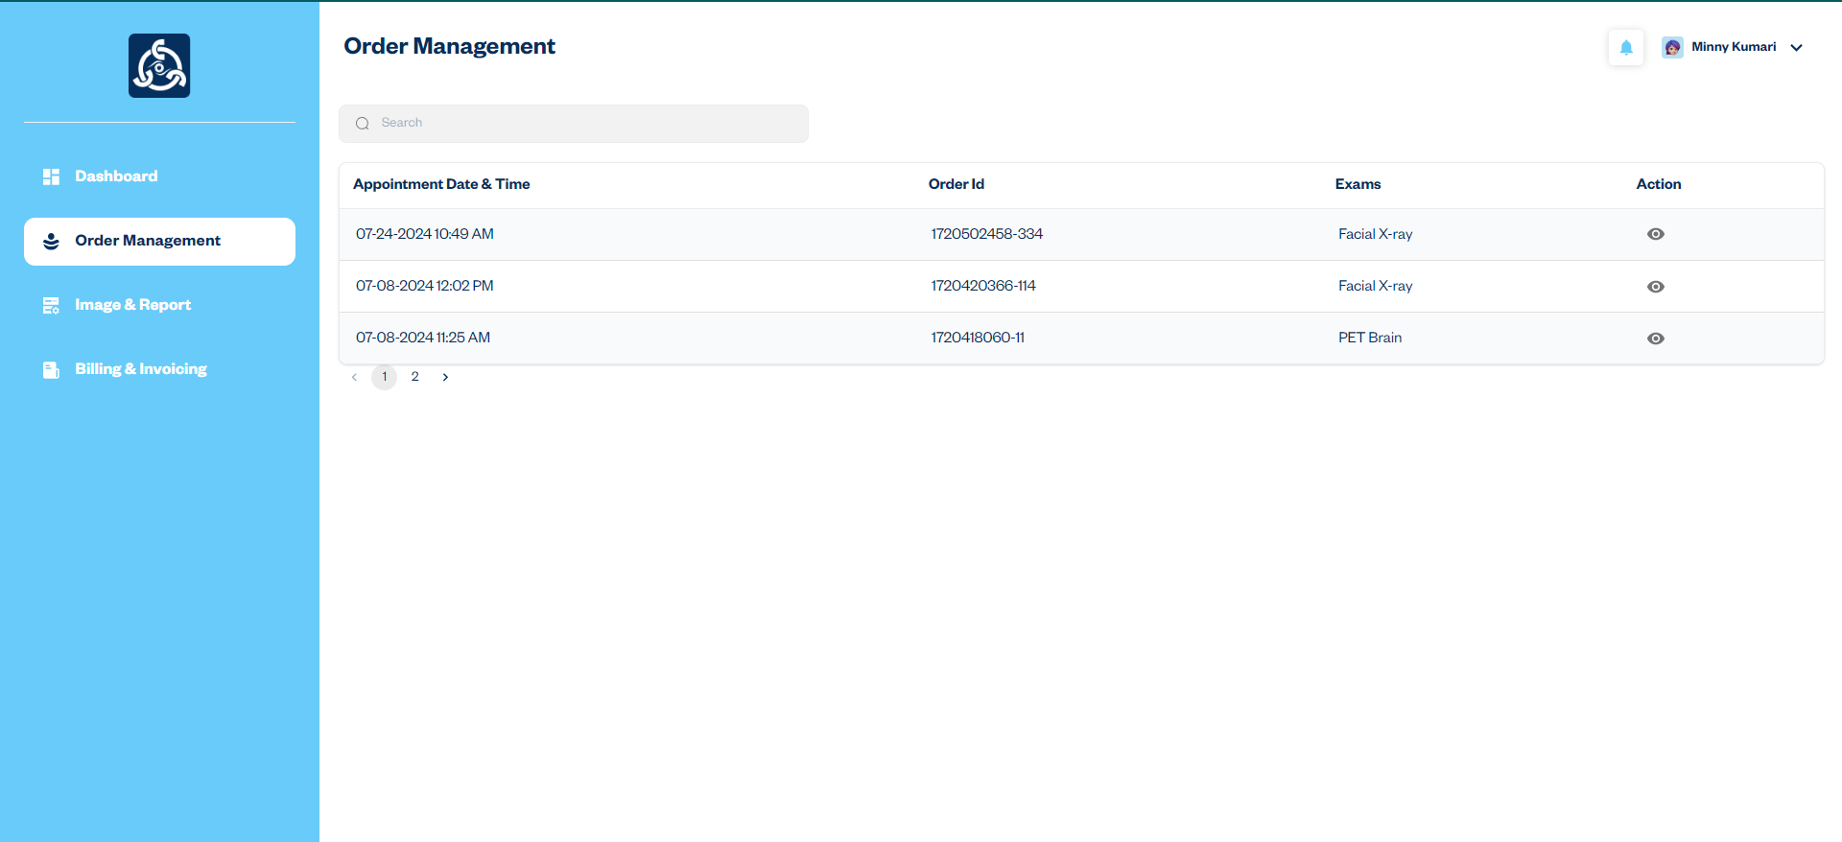

### 3. Image & Report

Description: The Image & Report module in the VOXXIL RIS web app is designed to manage and access patient images and reports associated with orders. This module ensures that healthcare providers can easily view, download, and print reports and images, facilitating efficient management of patient data.

Workflow:

1. The user accesses the "Image & Report" from the side navigation menu.

2. Review the list of all orders that include reports. The listing displays order ID, appointment date & time, and exams.

3. Click the "View" icon to access detailed information about the selected order, including report details and status updates for associated reports.

4. Click the "Report" icon to open the full report for the selected order.

5. In the report view, use the options to download the report as a PDF or print it directly from the application.

### 4. Billing & Invoicing Module

**Description:** The Billing & Invoicing module in the VOXXIL RIS web app is designed to manage and streamline the billing and invoicing process for patient services. This module facilitates the creation, tracking, and management of invoices, ensuring accurate financial operations and efficient revenue management.

Workflow:

1. The user can access the "Billing & Invoicing" from the side navigation menu.
2. View the invoice listing, which includes:
   * Invoice Date: The date when the invoice was issued.
   * Order ID: The identifier for the order.
   * Exams: The exams or services included in the invoice.
   * Action: Icons for viewing details.
3. Click the "View Details" icon to see detailed information about the invoice.
4. From the detail view, download the invoice as a PDF or print it directly.

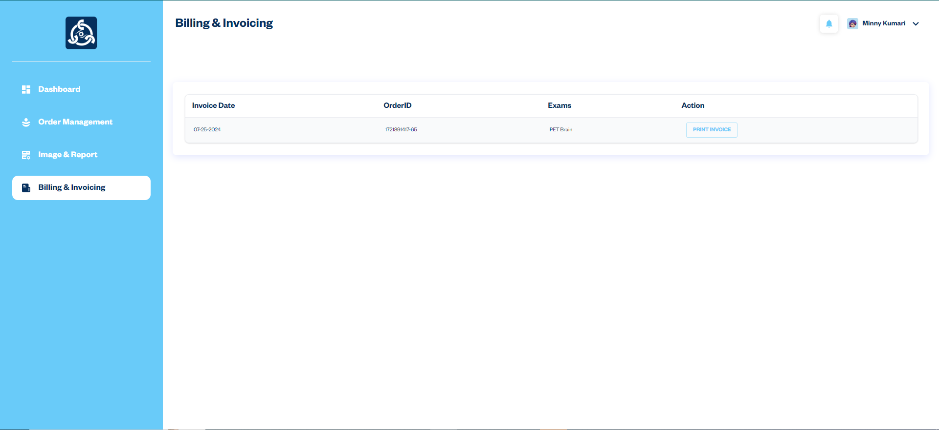

Header Profile Picture Dropdown

1. Profile Dropdown Access:

* Click on the profile picture located in the top right corner of the header to open the profile dropdown menu.

2. Dropdown Options:

* Edit Profile**:** Allows the user to update personal details, such as personal information, contact information, emergency contact information, insurance information, referring physician information, personal medical history, family medical history, lifestyle and consent & acknowledgements. Users can also change their password within this section.
* Logout**:** Clicking "Logout" will end the current session and redirect the user to the login page.

Edit Profile Form

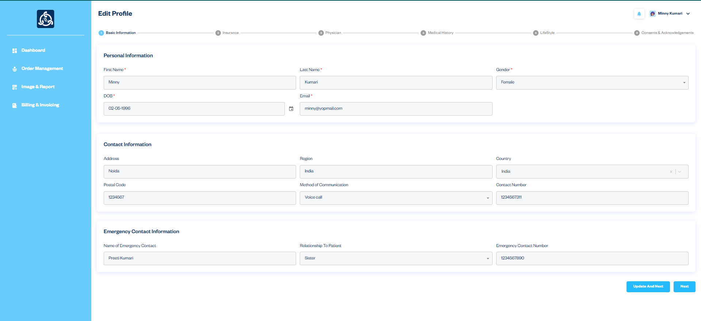

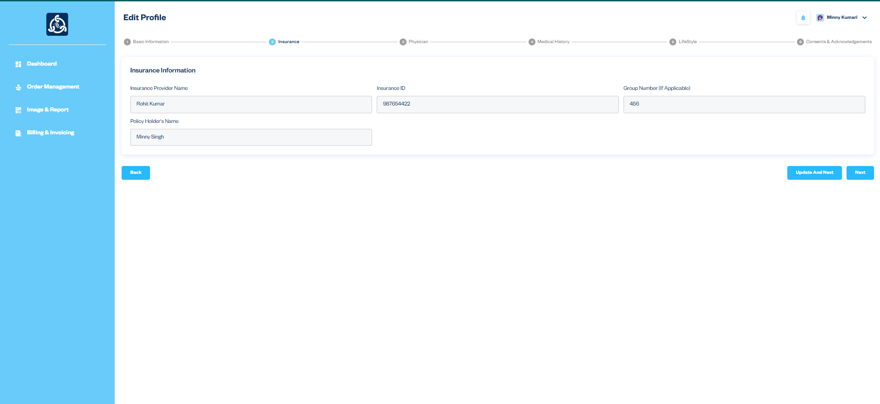

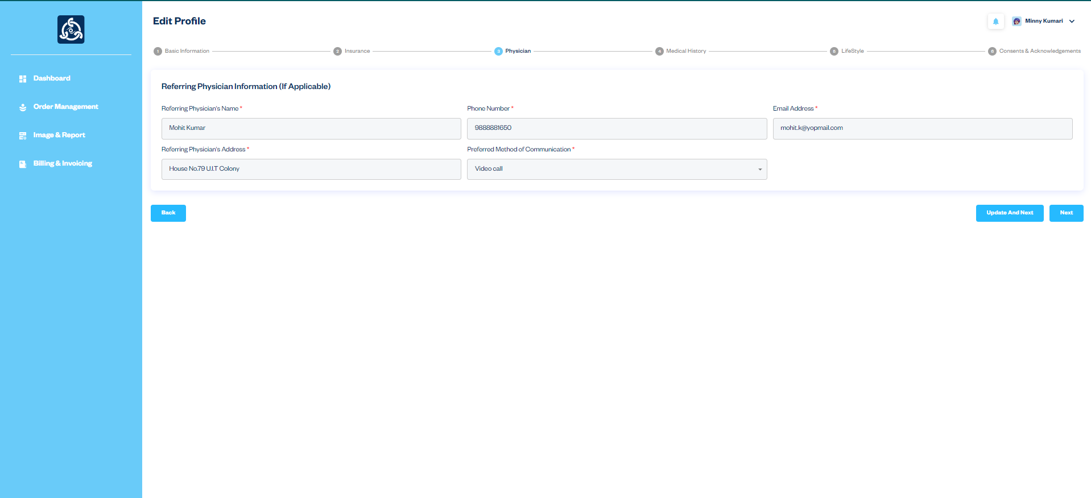

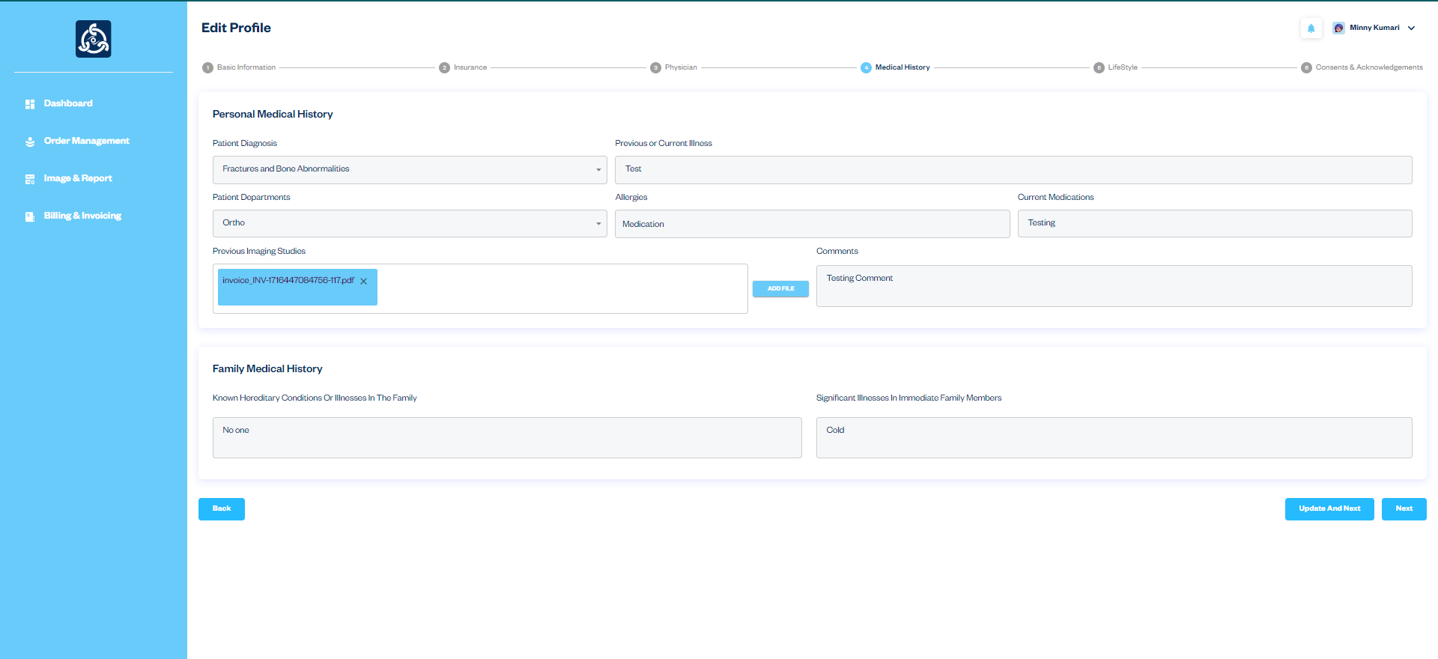

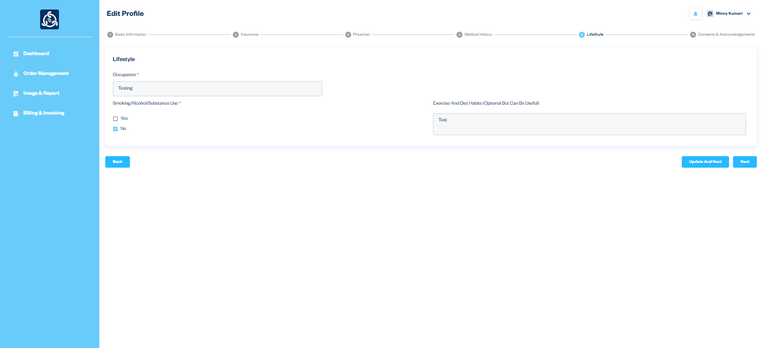

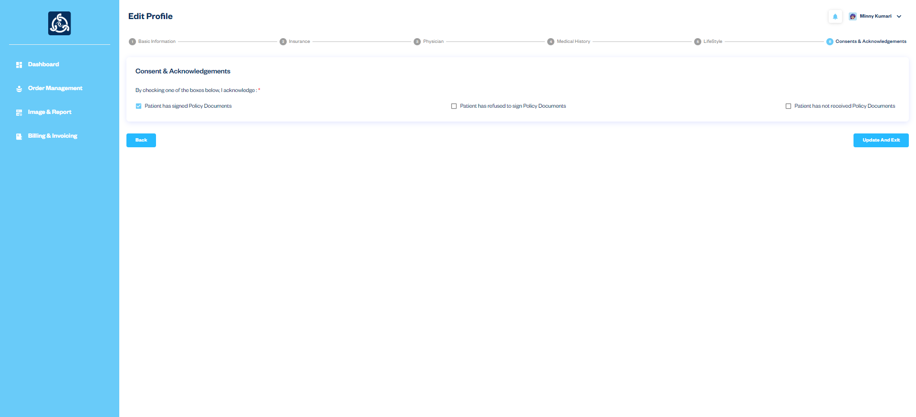

## Conclusion

### Summary

This document has provided a comprehensive overview of the VOXXIL RIS app, detailing its key modules and functionalities. By integrating patient management, appointment scheduling, referrals, billing, and reporting, the VOXXIL RIS app enhances operational efficiency and patient care. The app centralizes patient records, streamlines appointment bookings, manages referrals seamlessly, simplifies billing processes, and provides actionable insights through detailed reporting. These features collectively reduce administrative burdens and improve the overall quality of healthcare services.